Tour ID: 154495  
Tour Name: 4 Day - Volcano Hike, Golden Circle, South Coast, Jökulsárlón & Ice Cave

Tour destinations: ['Reykjavik', 'Kirkjubaejarklaustur', 'Gullfoss', 'Seljaland', 'Thingvellir National Park', 'Vik', 'Skogafoss', 'Dover', 'Geysir', 'Skaftafell', 'Jokulsarlon', 'Reynisfjara', 'Reynisdrangar Cliffs', 'Vatnajokull National Park']

Tour destinations images:

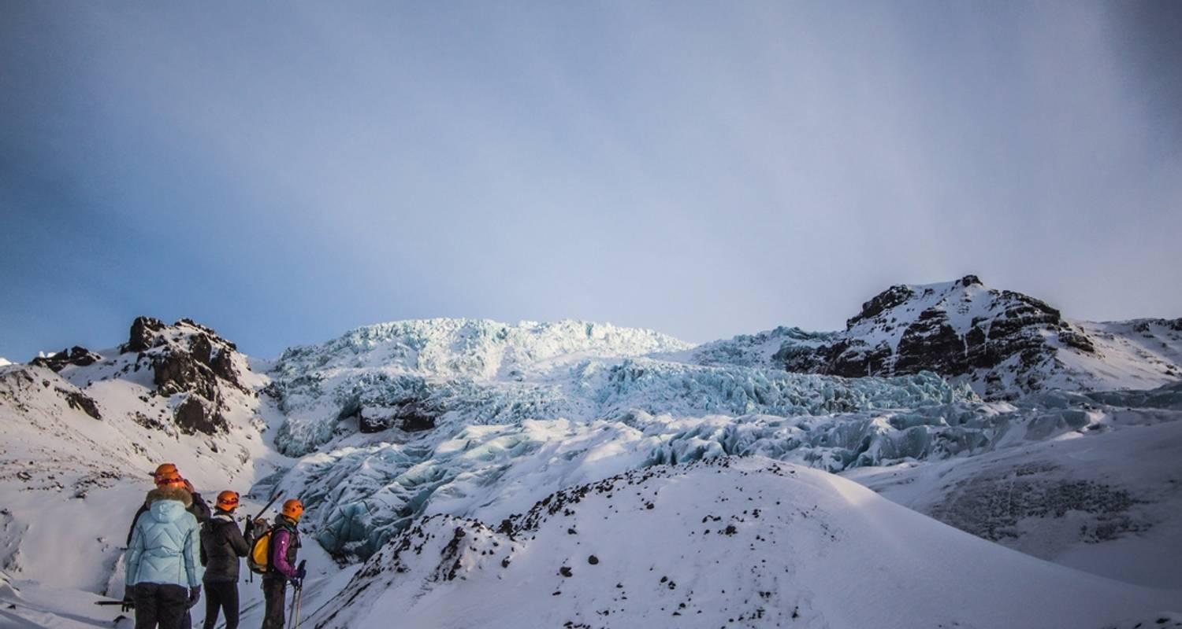

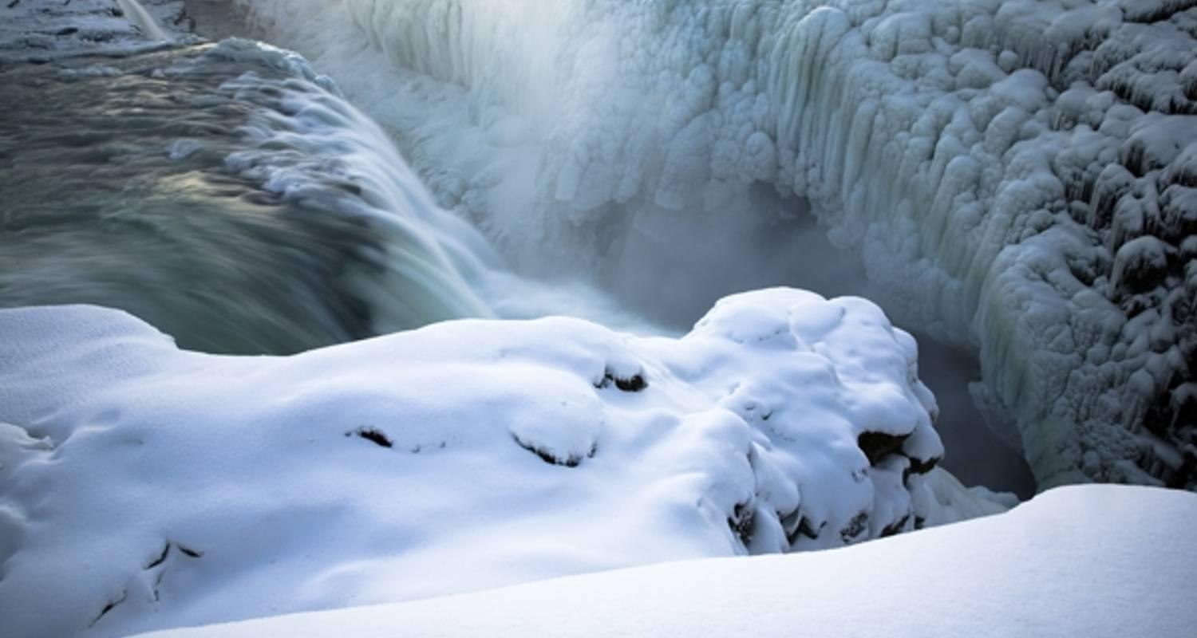

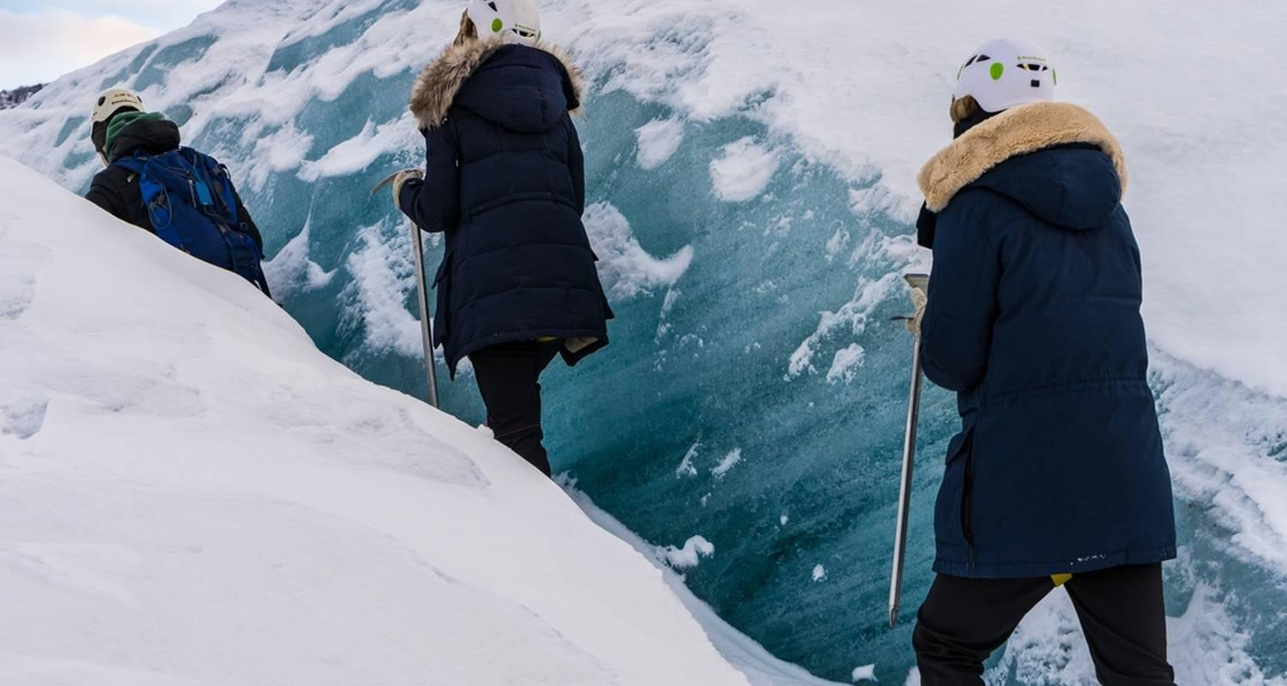

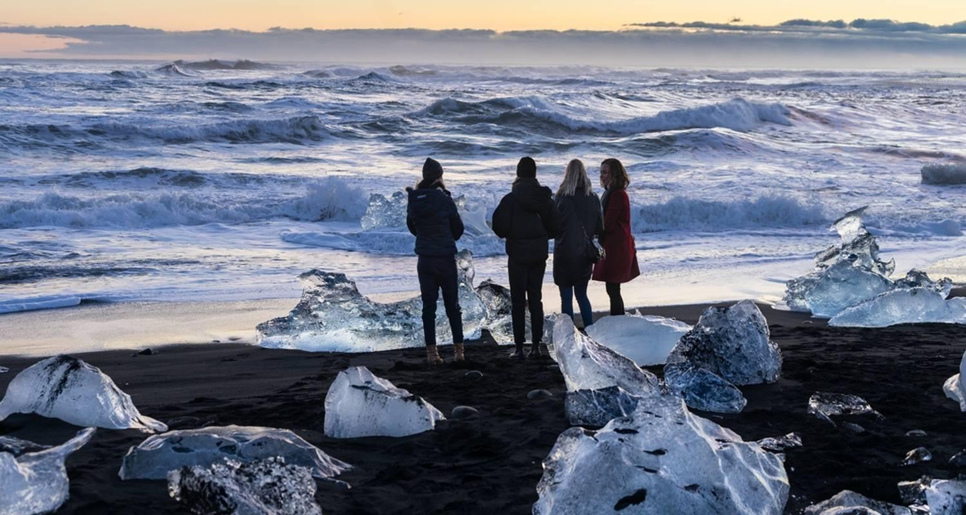

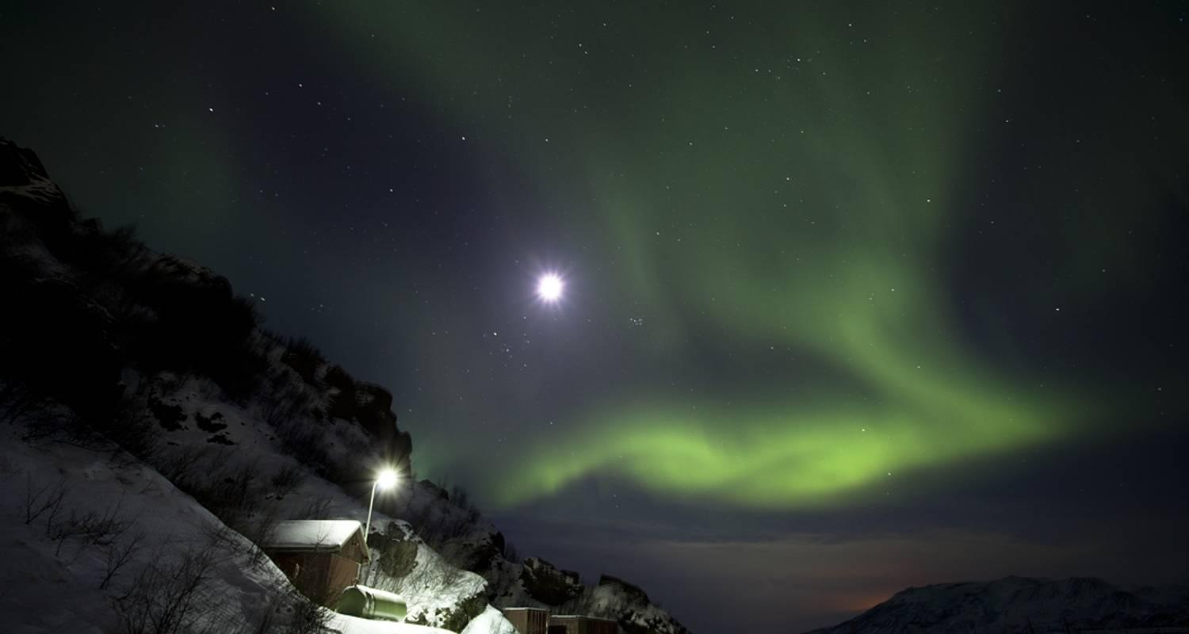

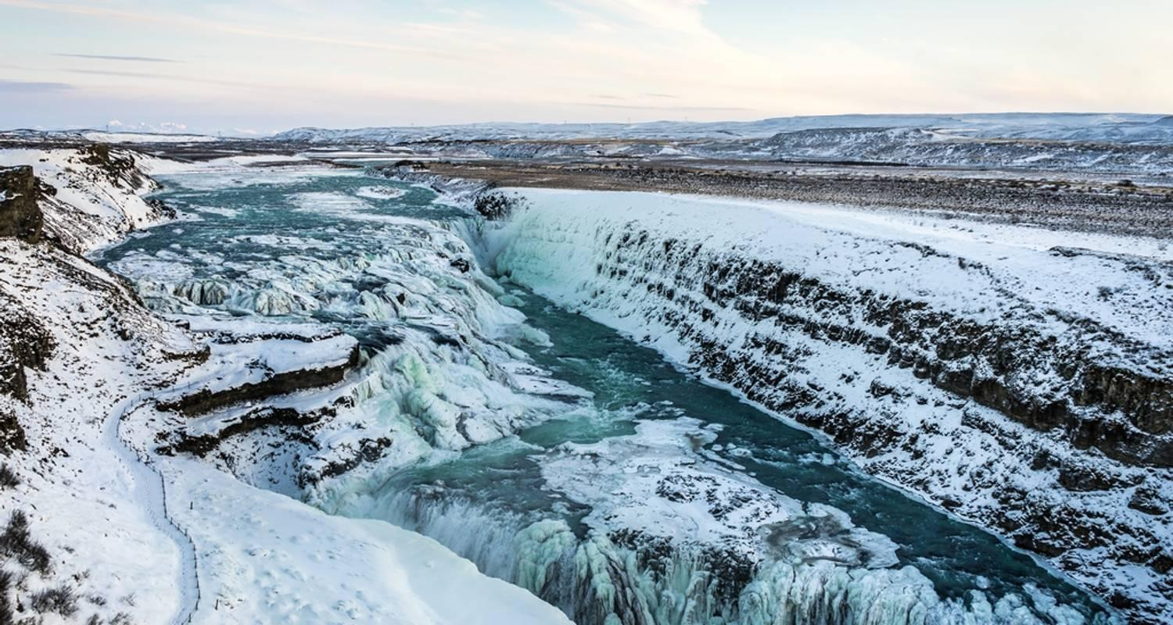

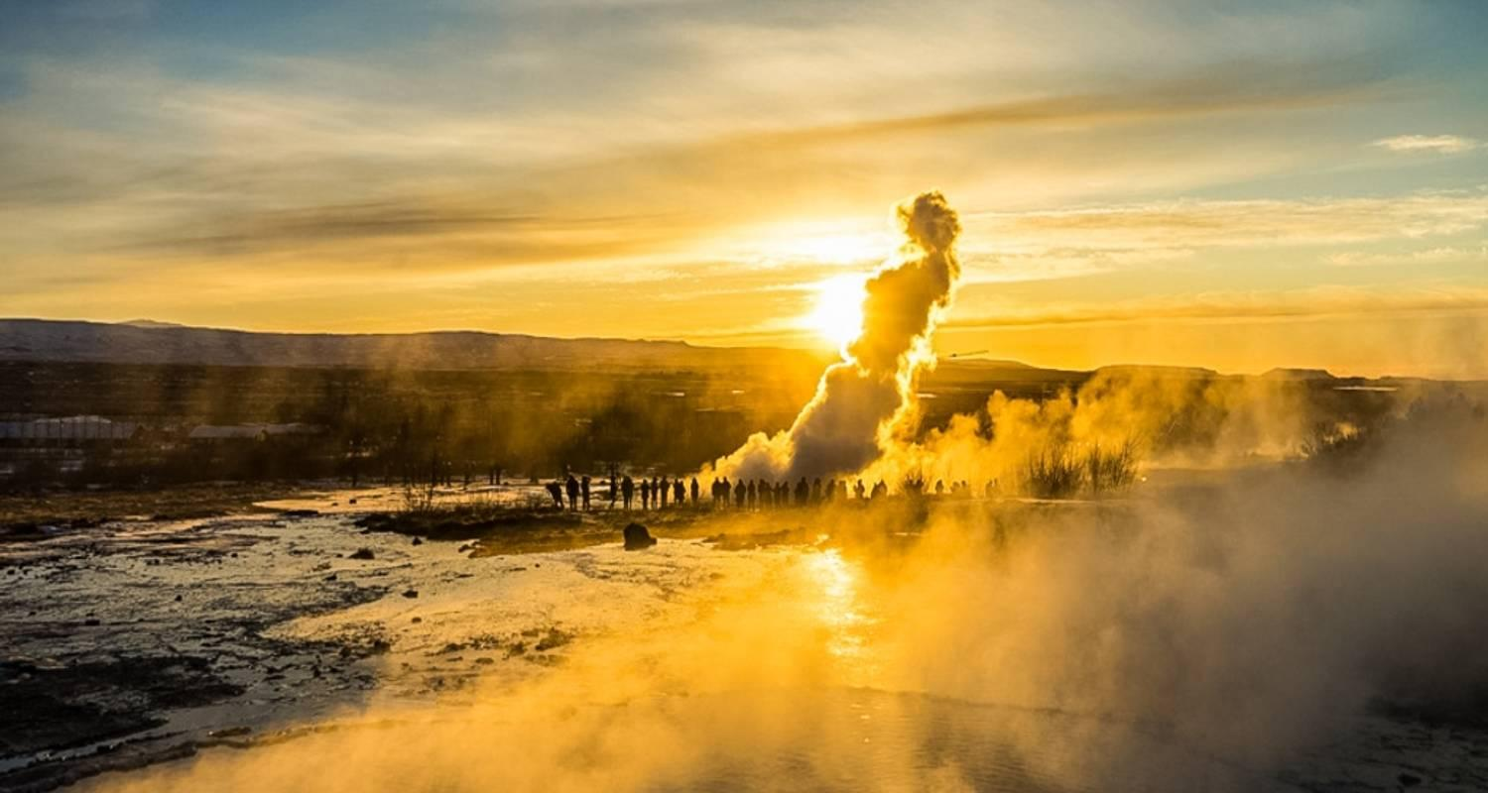

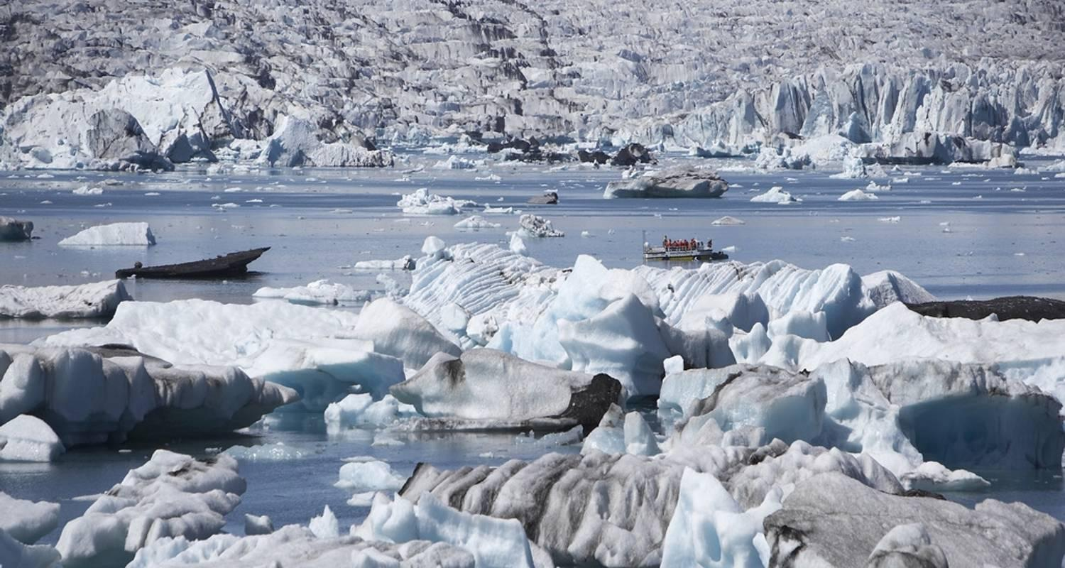

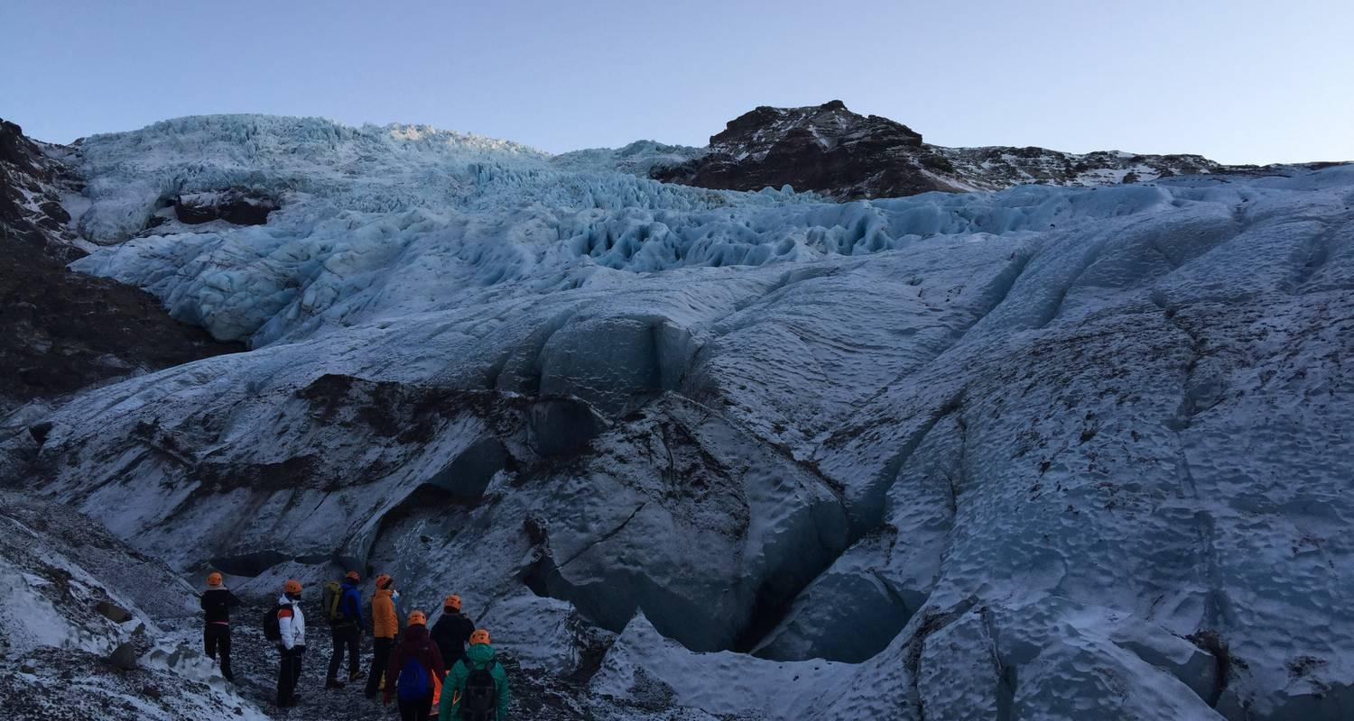

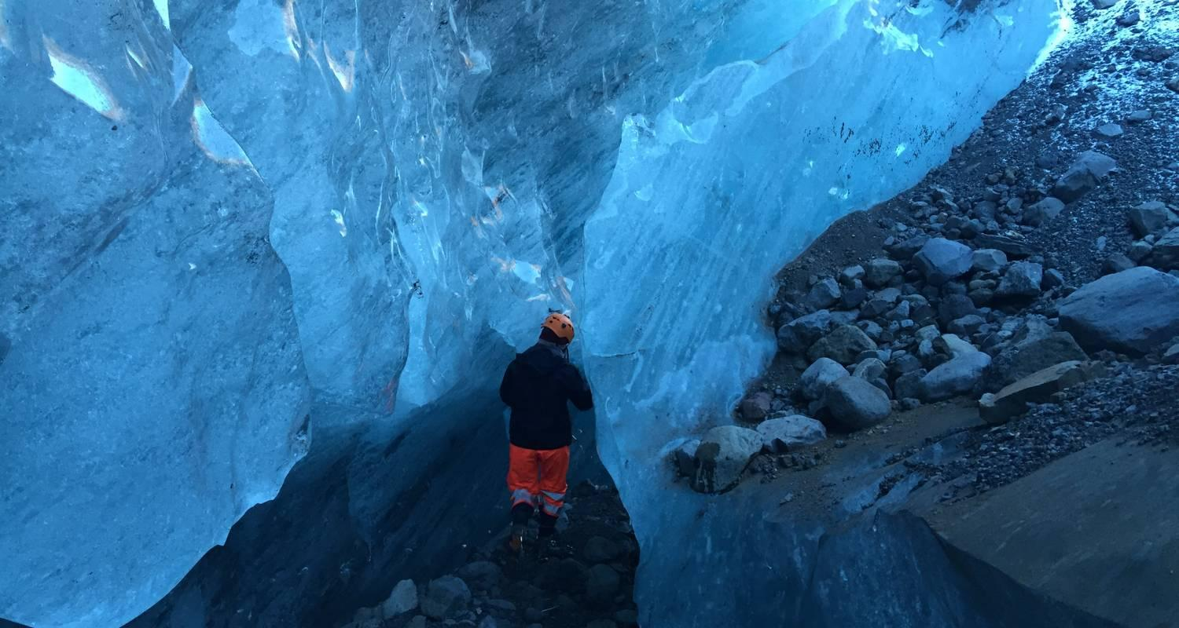

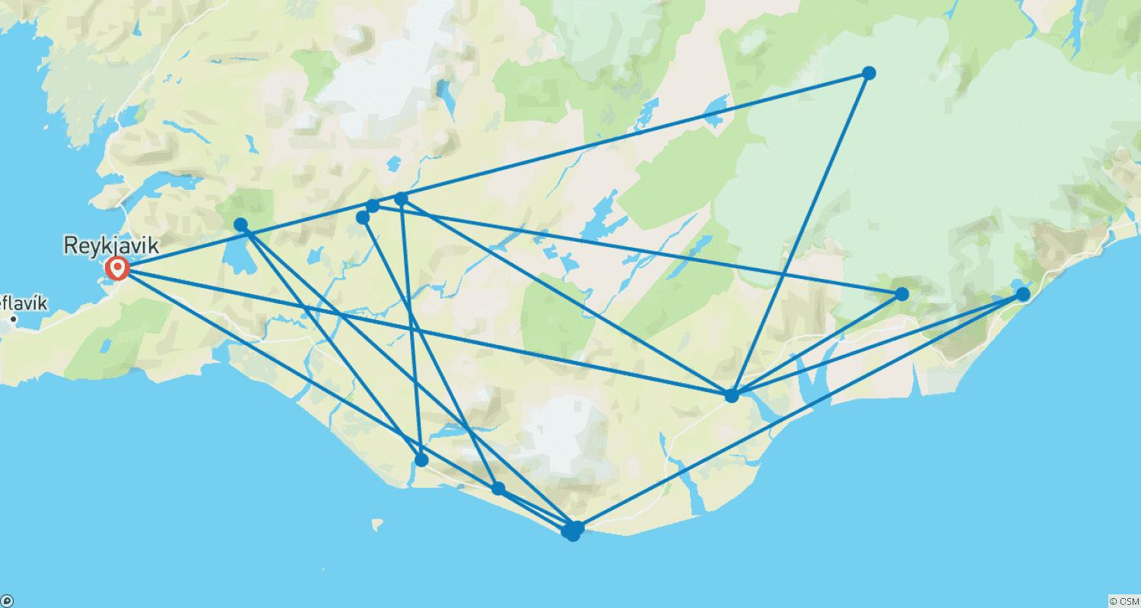

Tour ID: 154792  
Tour Name: South Greenland Explorer (from Iceland)

Tour destinations: ['Reykjavik', 'Narsaq', 'Nanortalik', 'Qaqortoq', 'Narsarsuaq']

Tour destinations images:

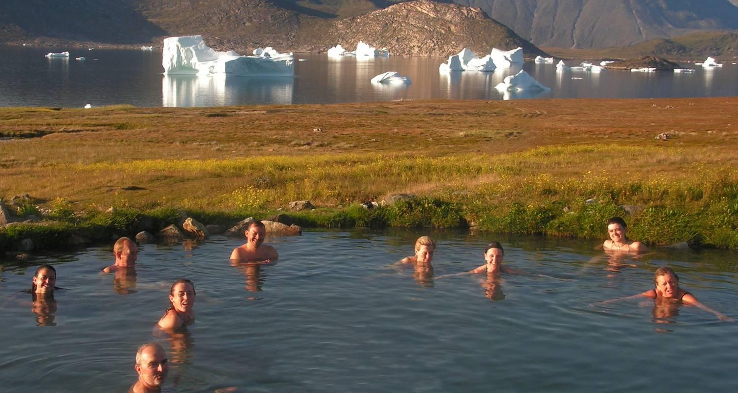

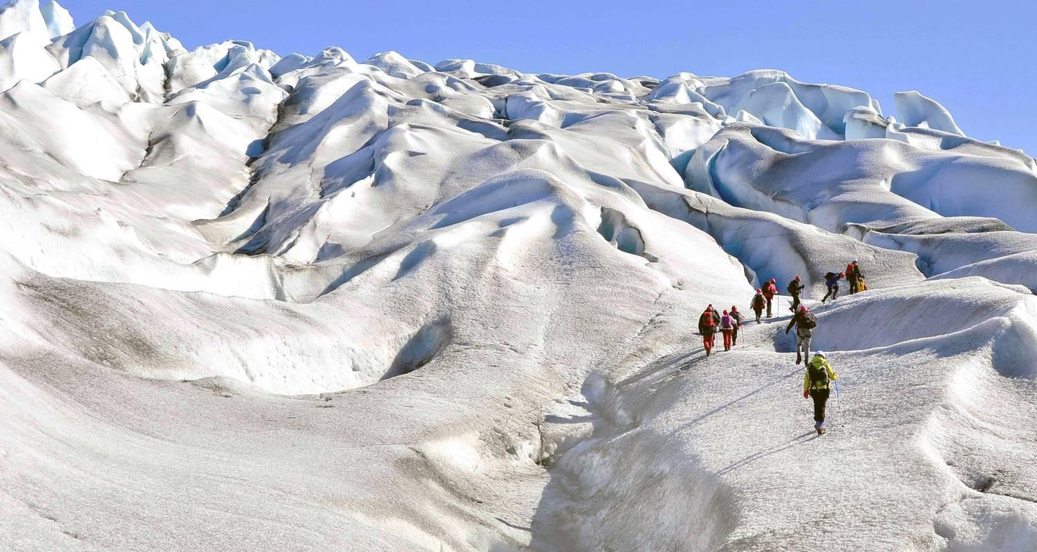

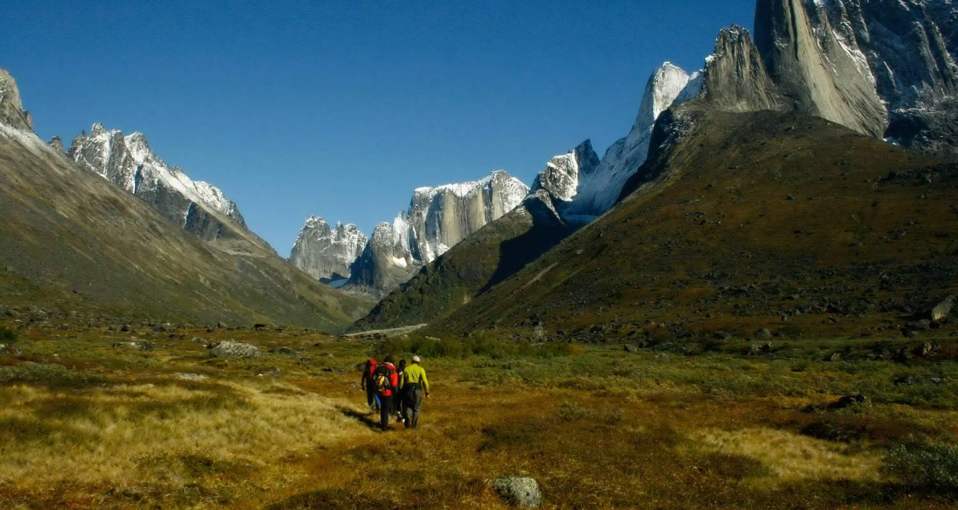

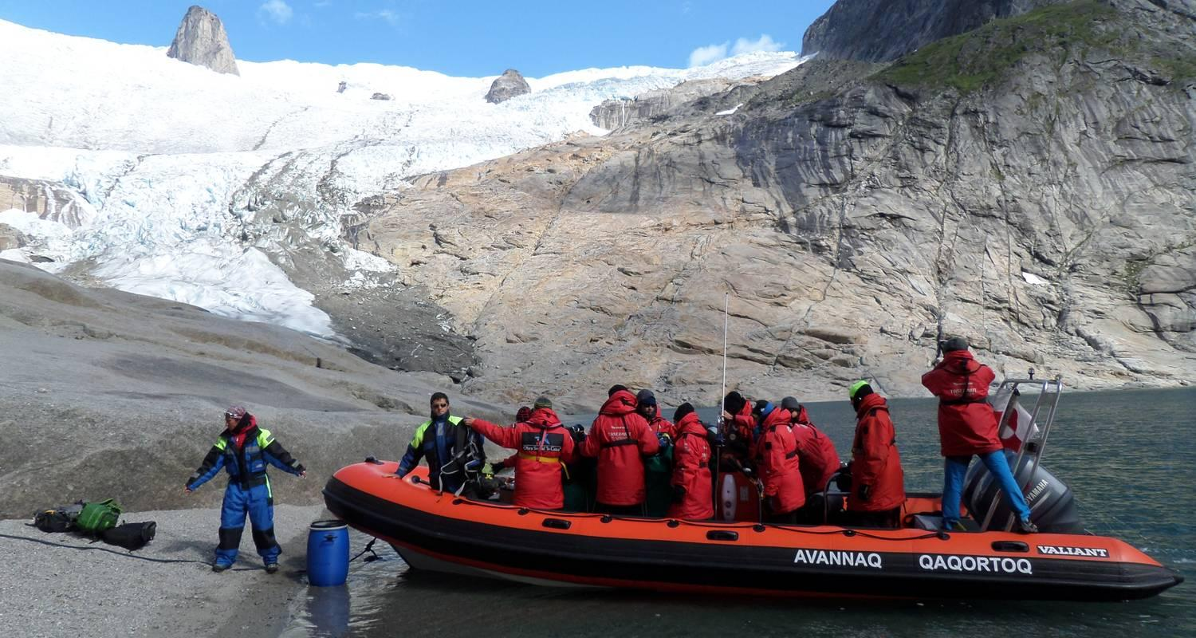

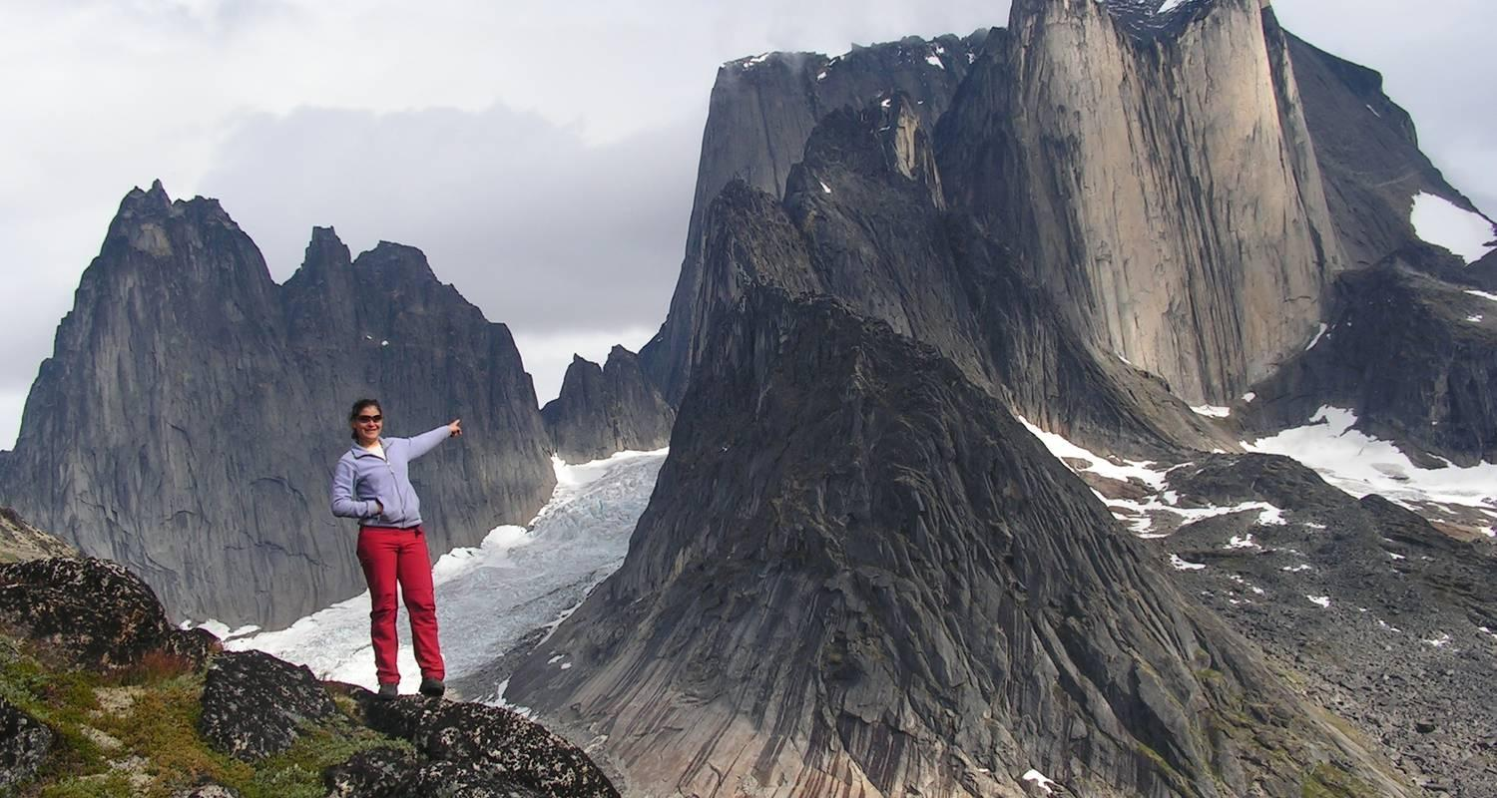

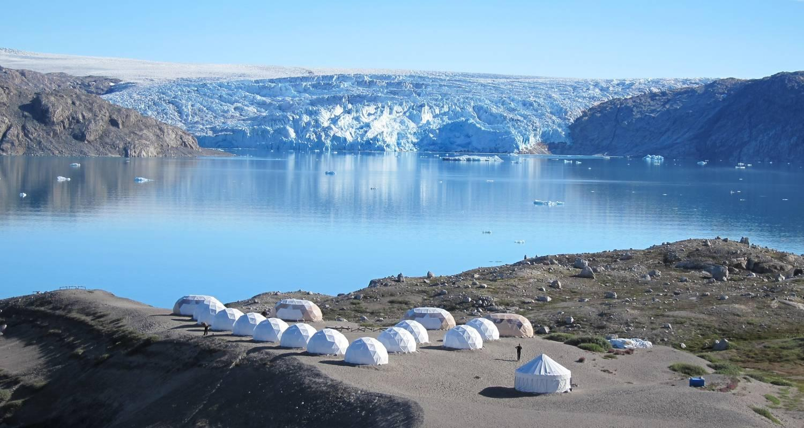

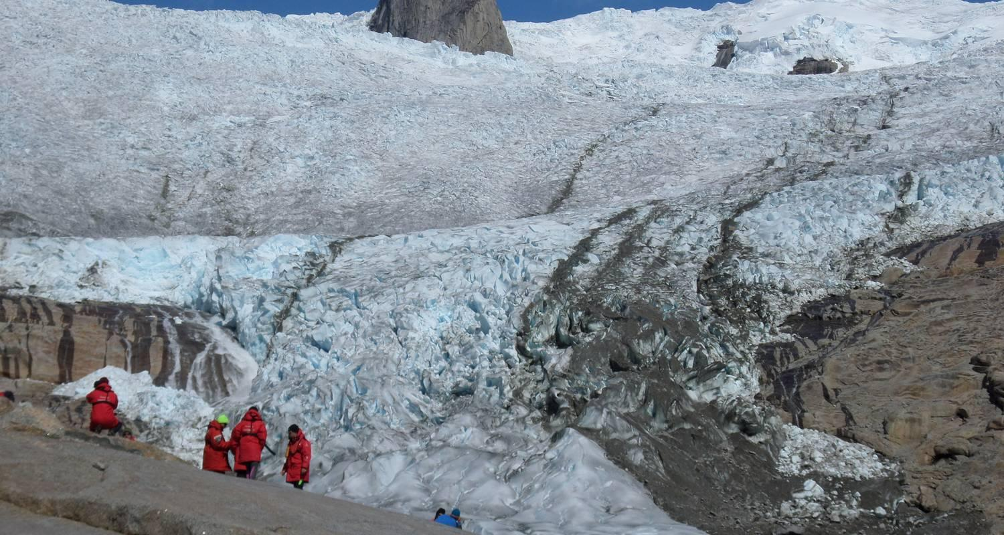

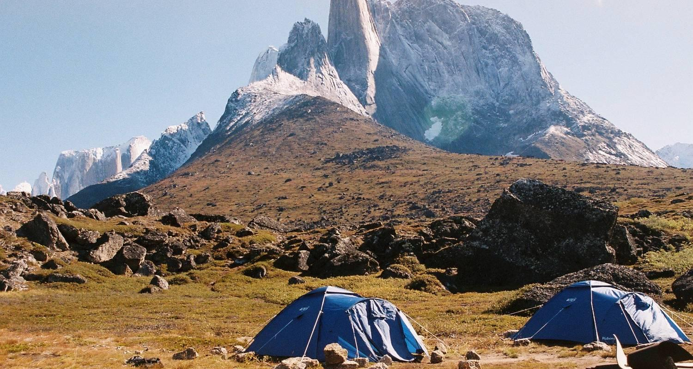

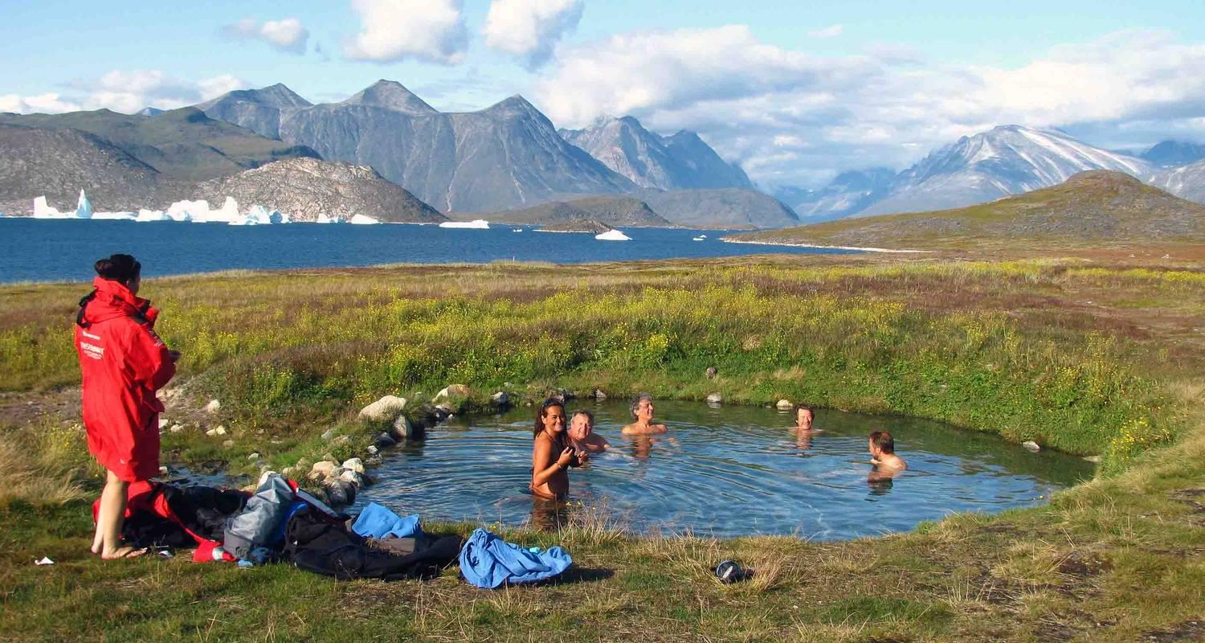

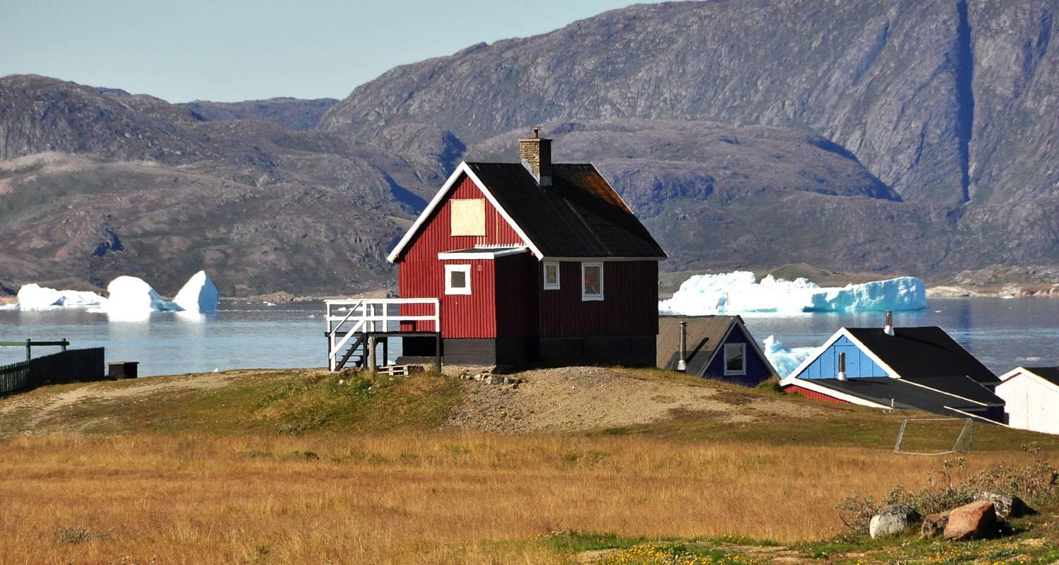

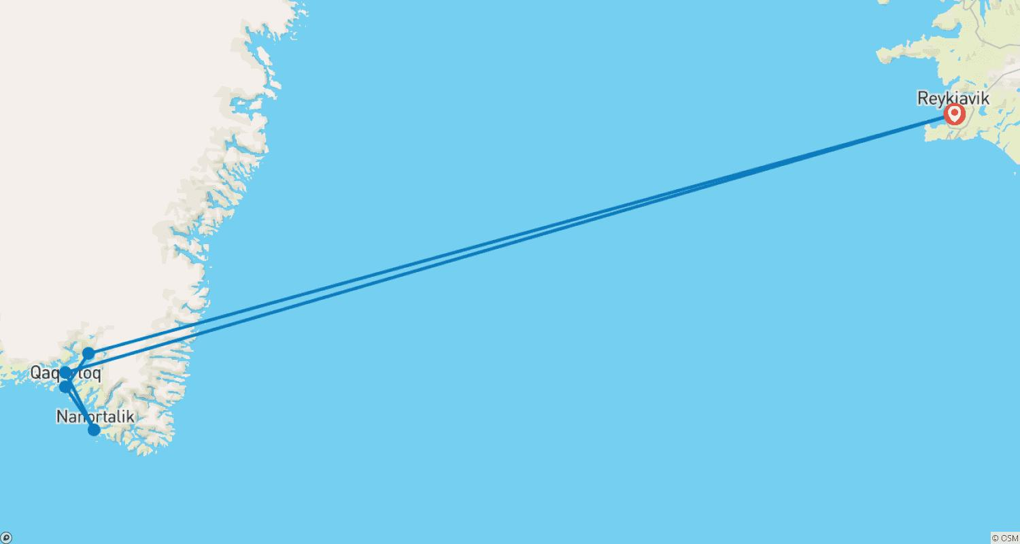

Tour ID: 154817  
Tour Name: Exclusive Adventure (from Iceland)

Tour destinations: ['Reykjavik', 'Narsarsuaq', 'Narsaq', 'Qaqortoq']

Tour destinations images:

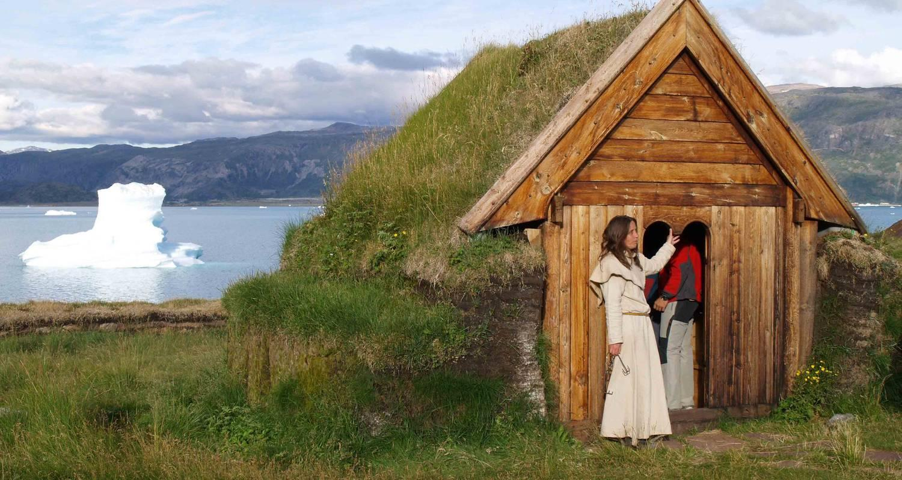

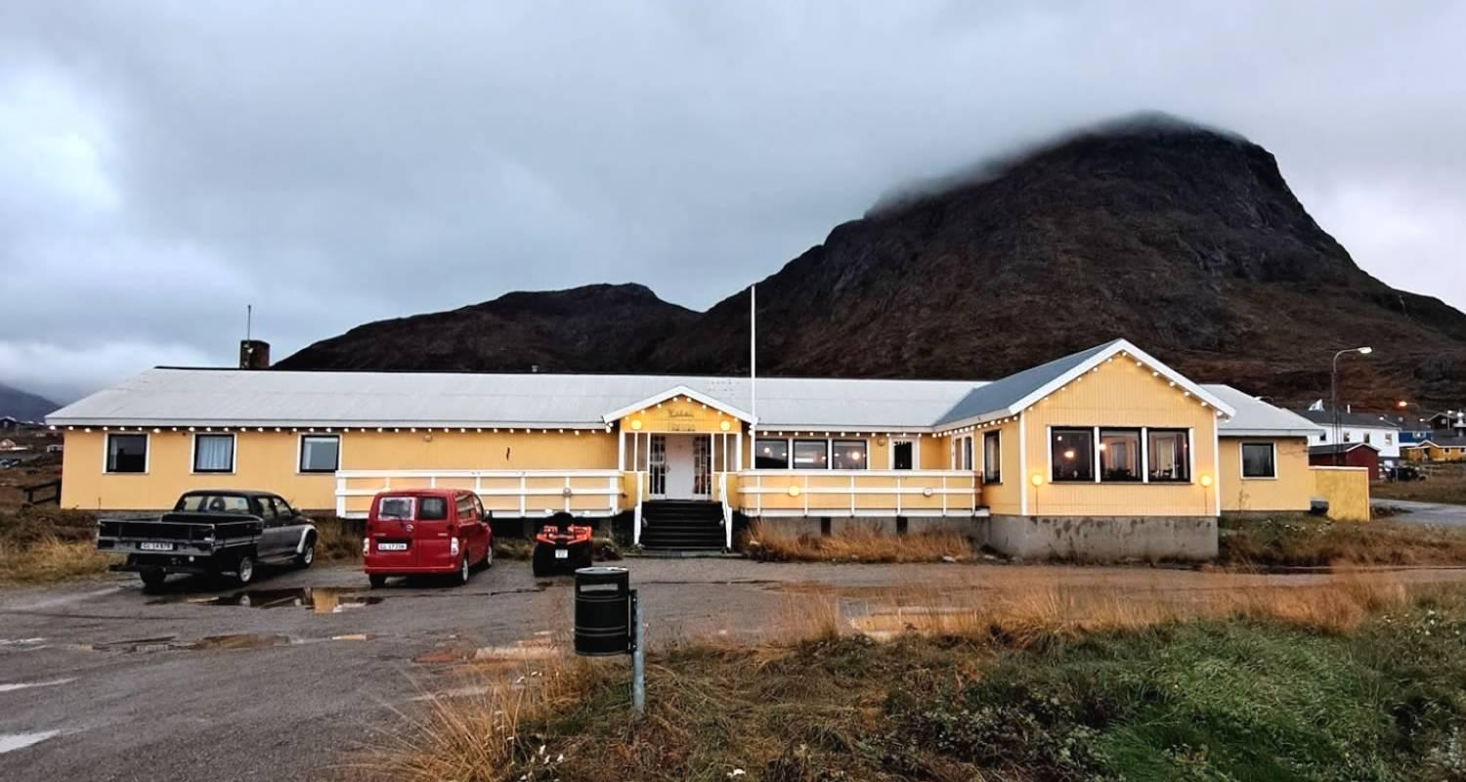

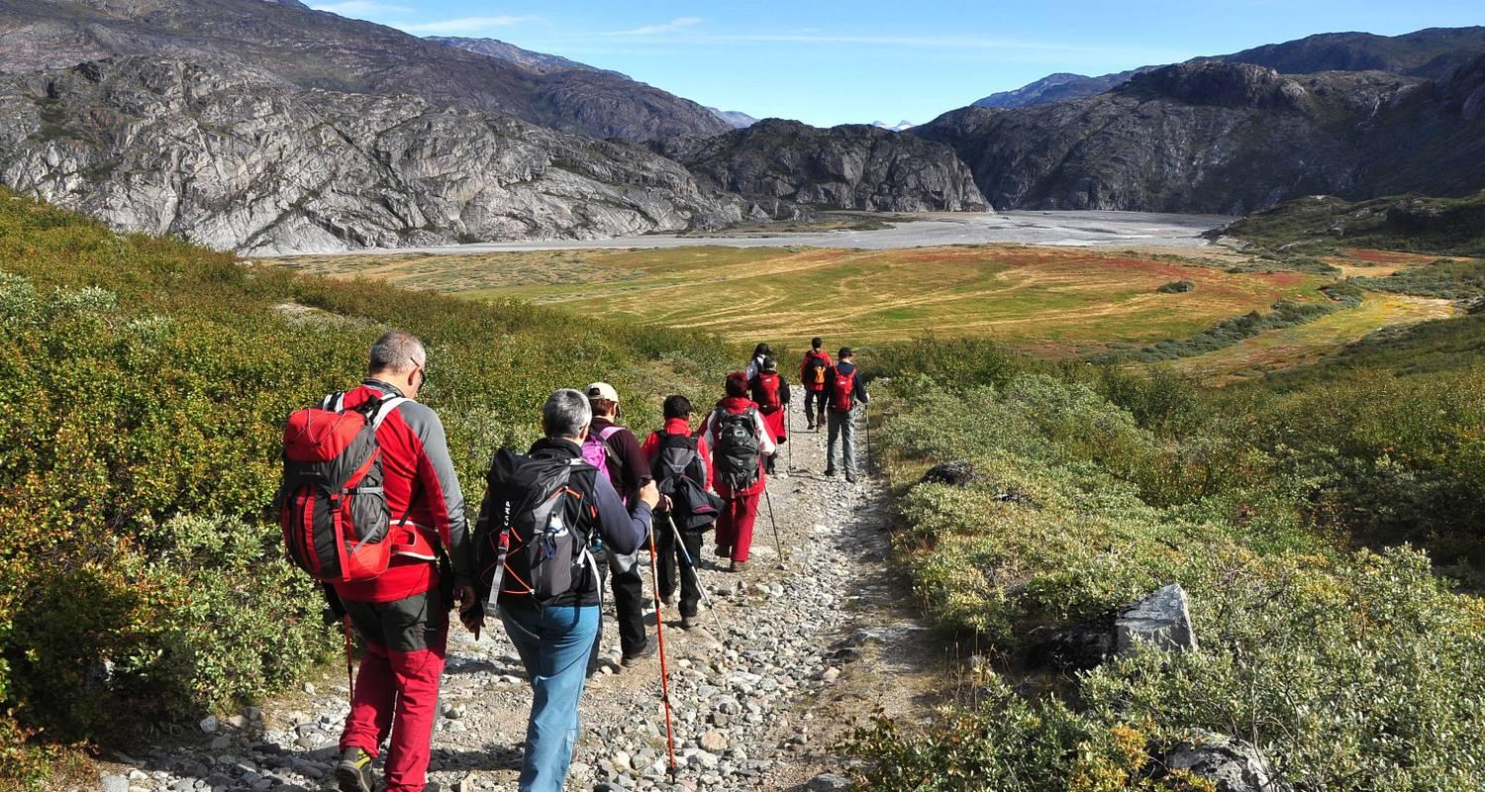

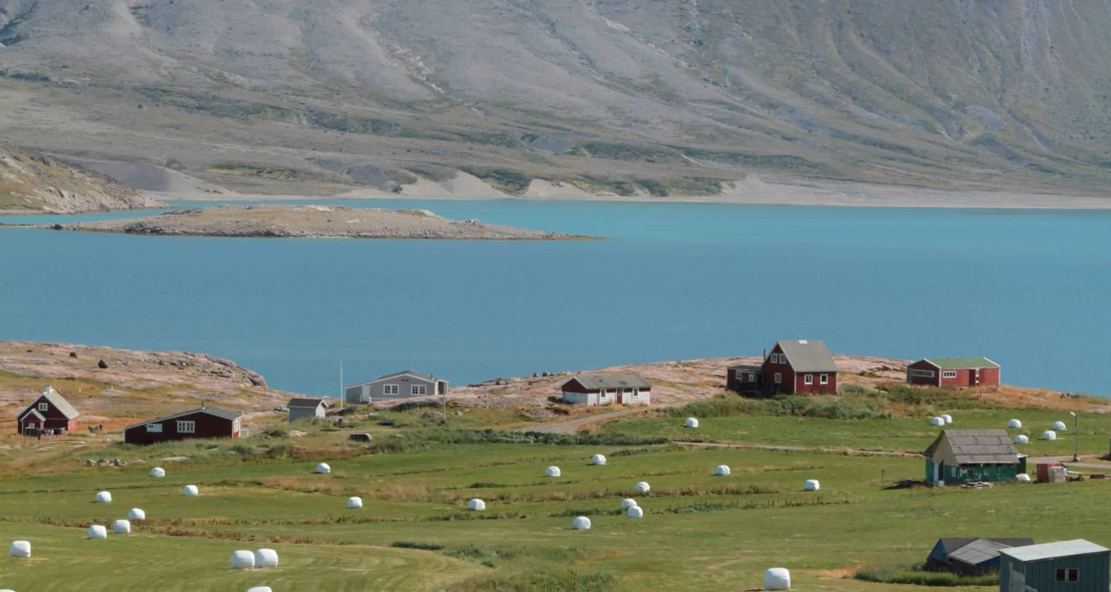

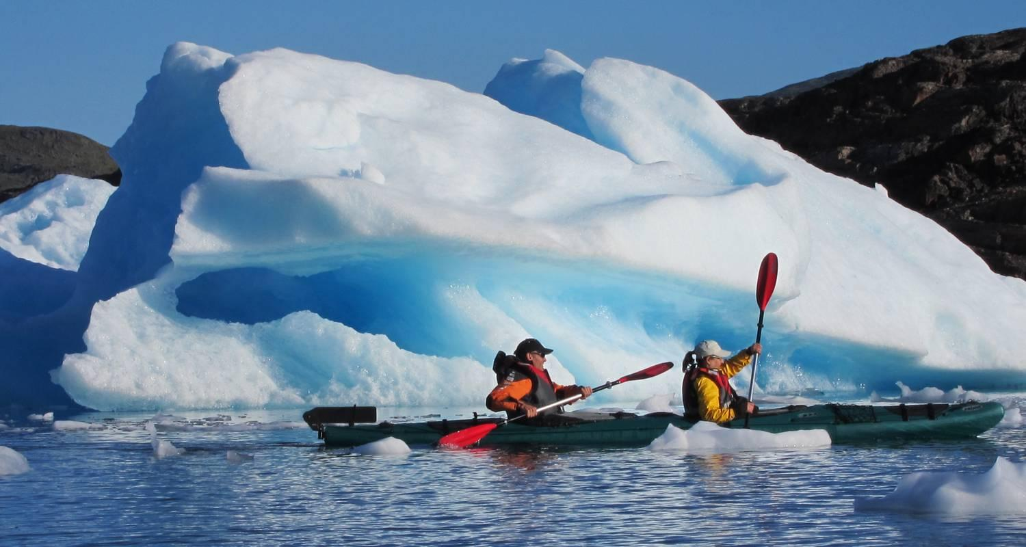

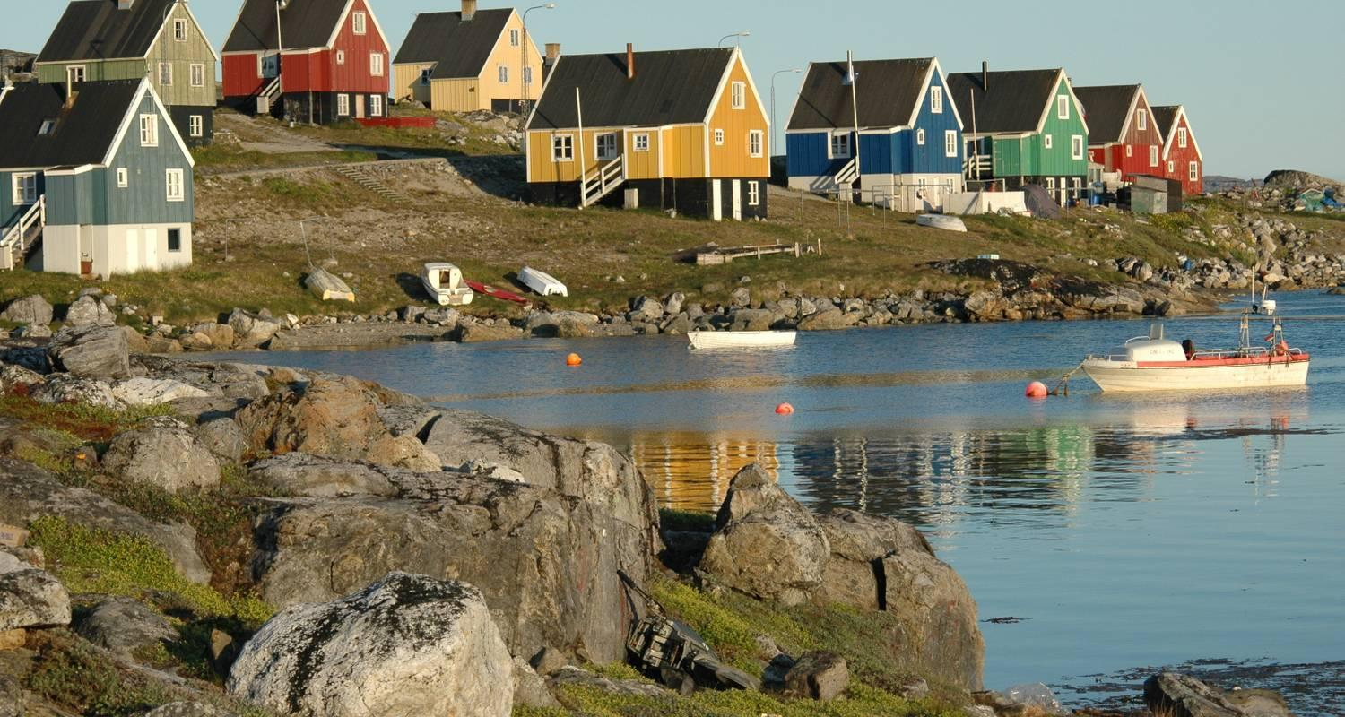

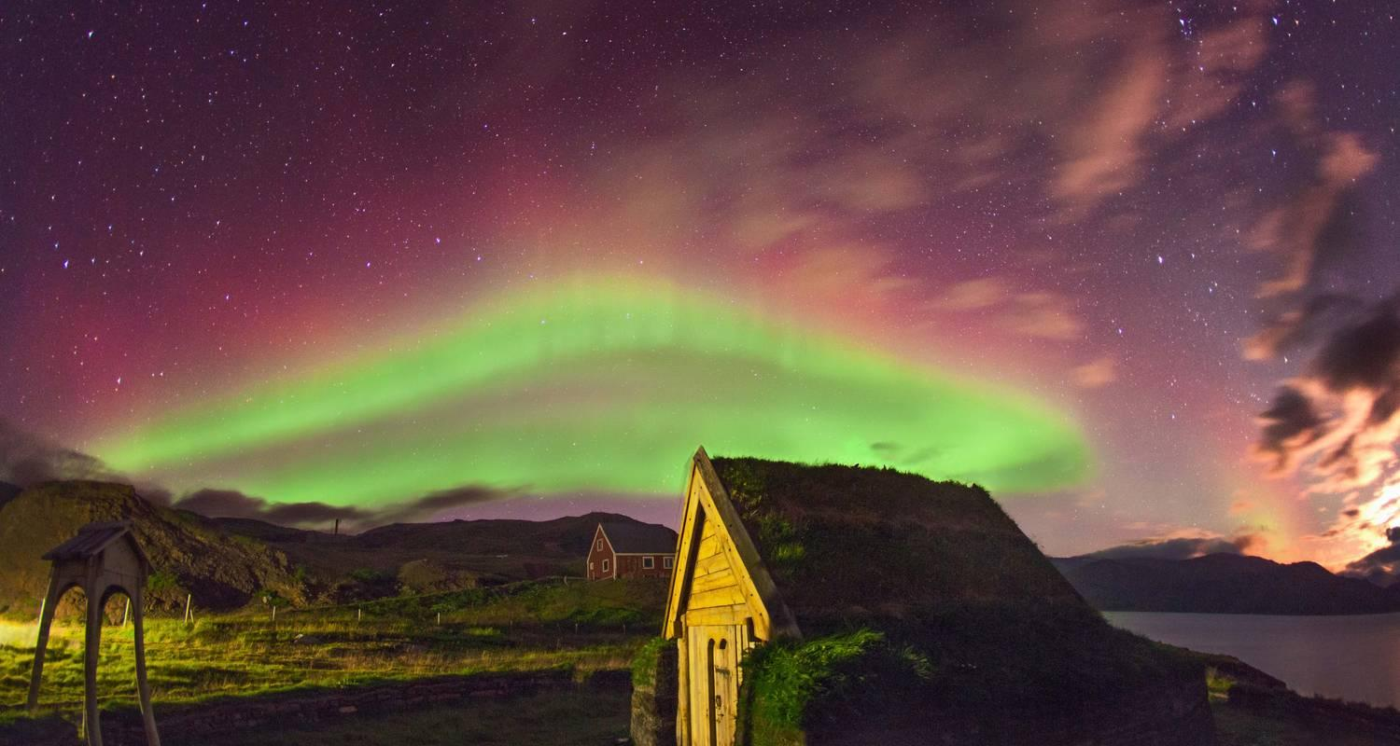

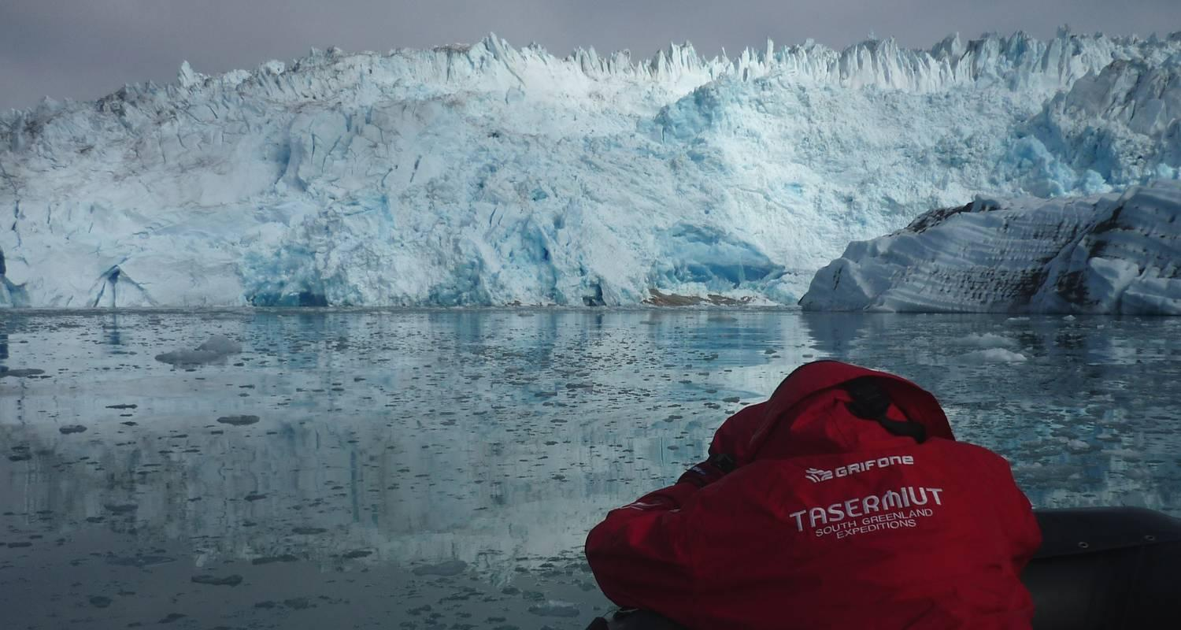

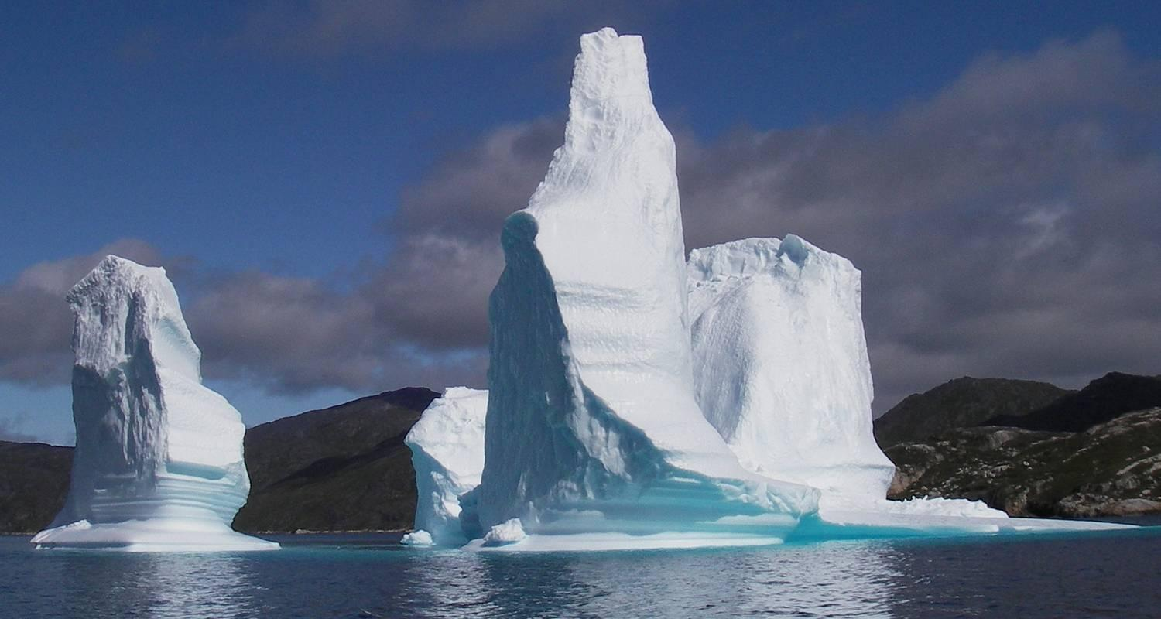

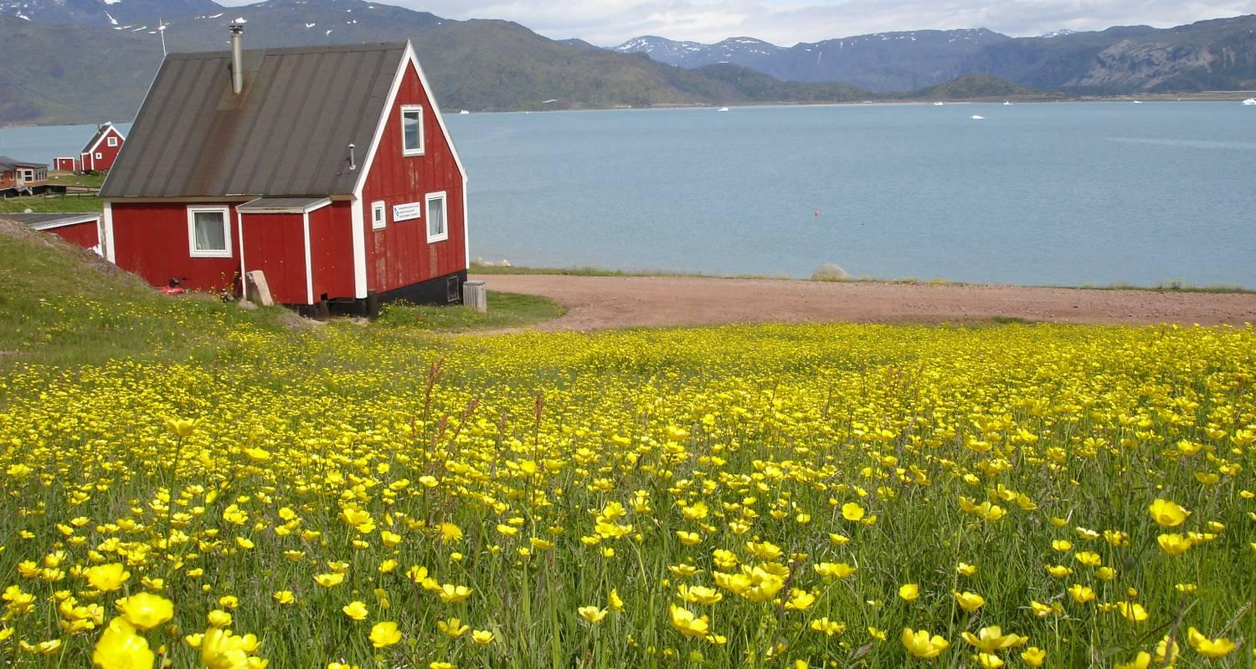

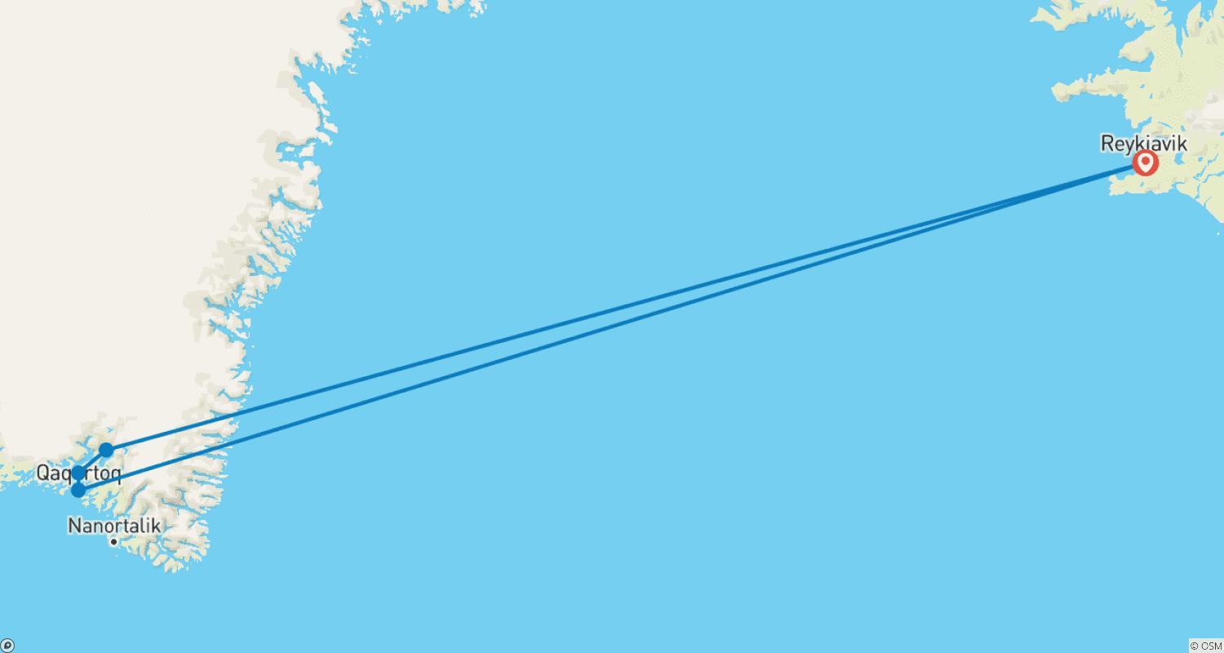

Tour ID: 155222  
Tour Name: Iceland Winter Adventure

Tour destinations: ['Reykjavik', 'Akureyri', 'Hrísey', 'Godafoss', 'Myvatn', 'Egilsstadir', 'Jokulsarlon', 'Vik', 'Gullfoss']

Tour destinations images:

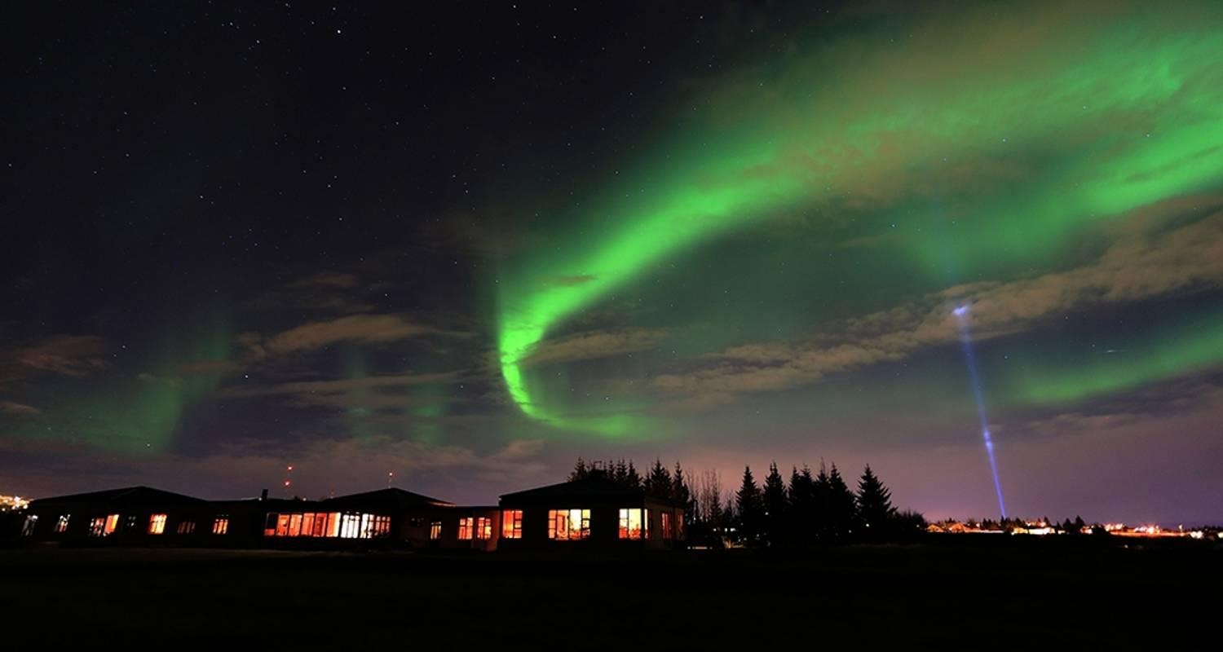

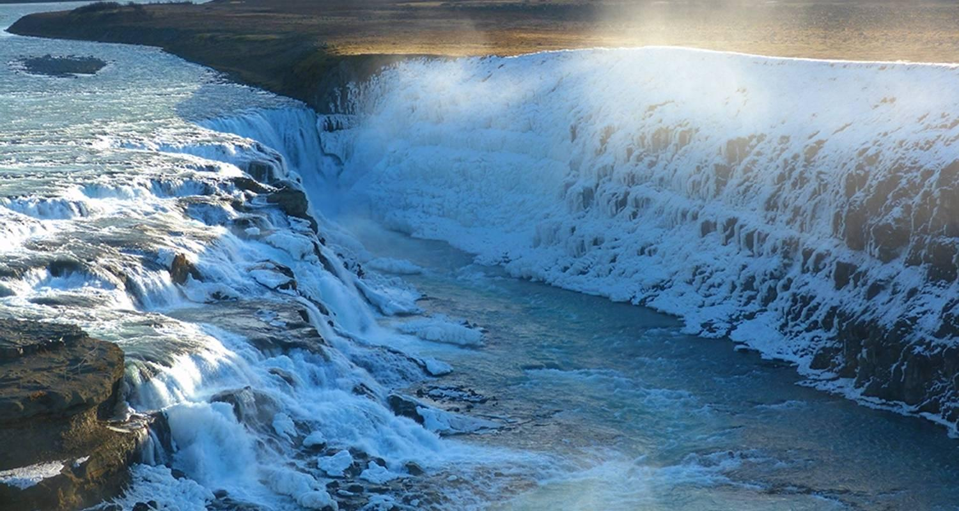

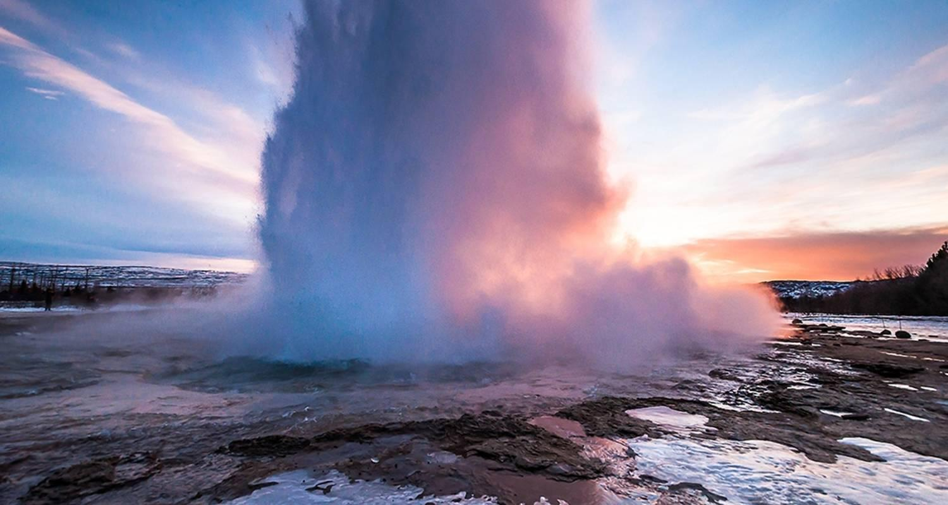

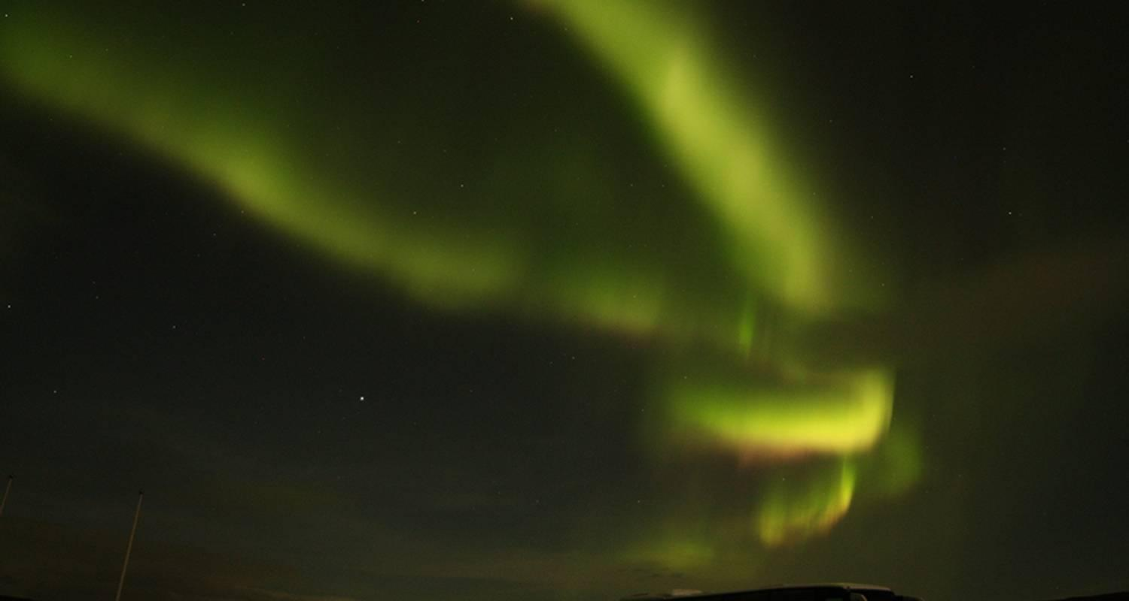

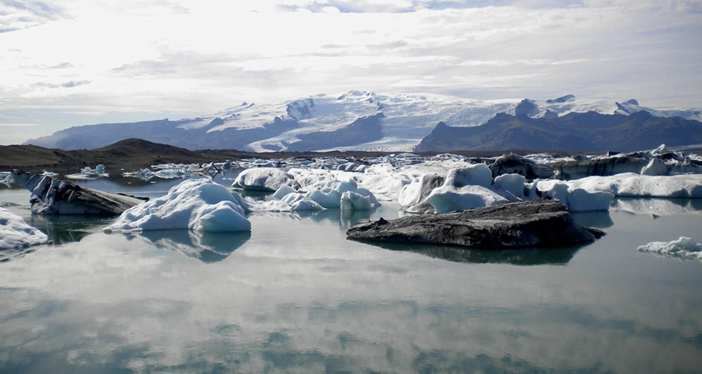

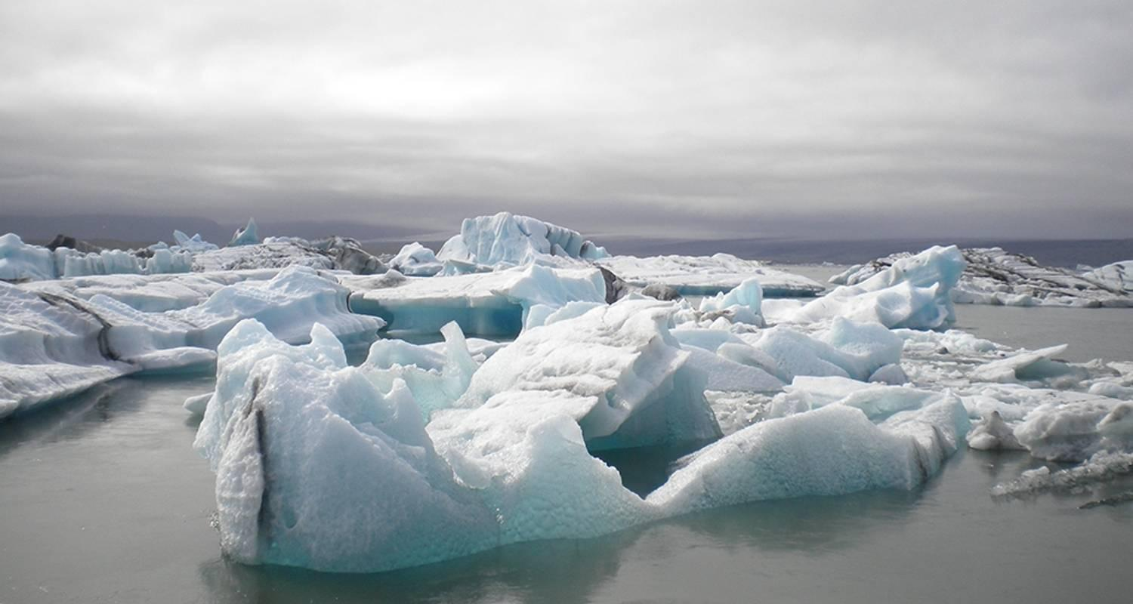

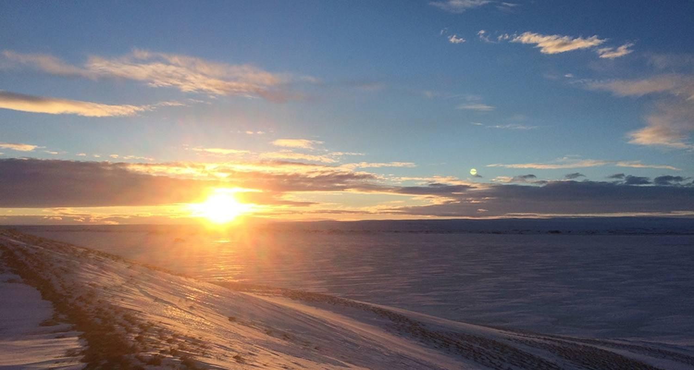

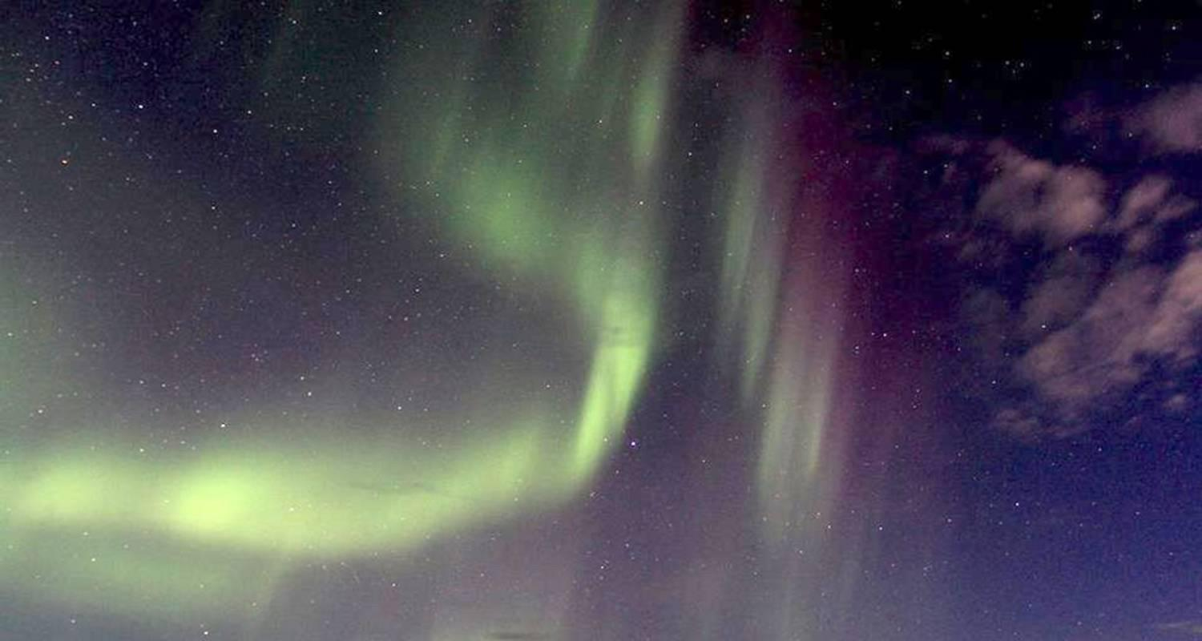

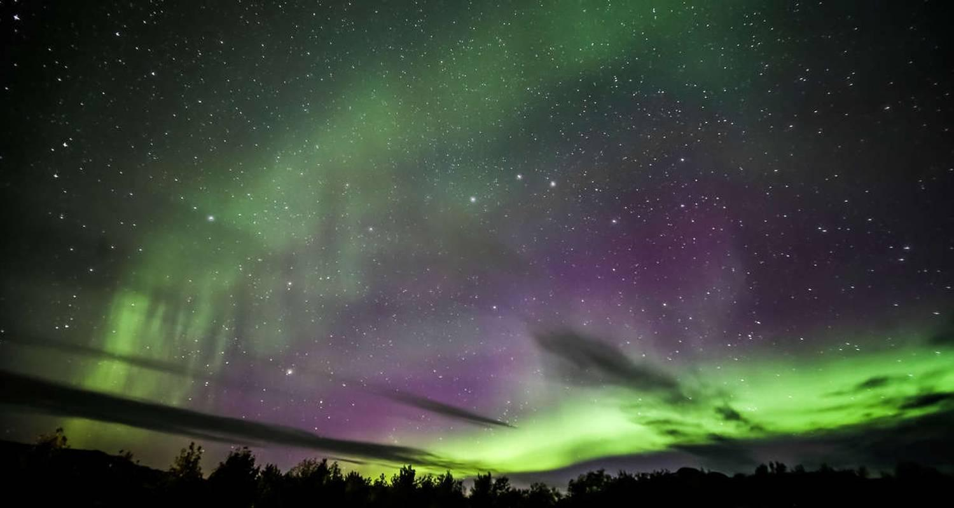

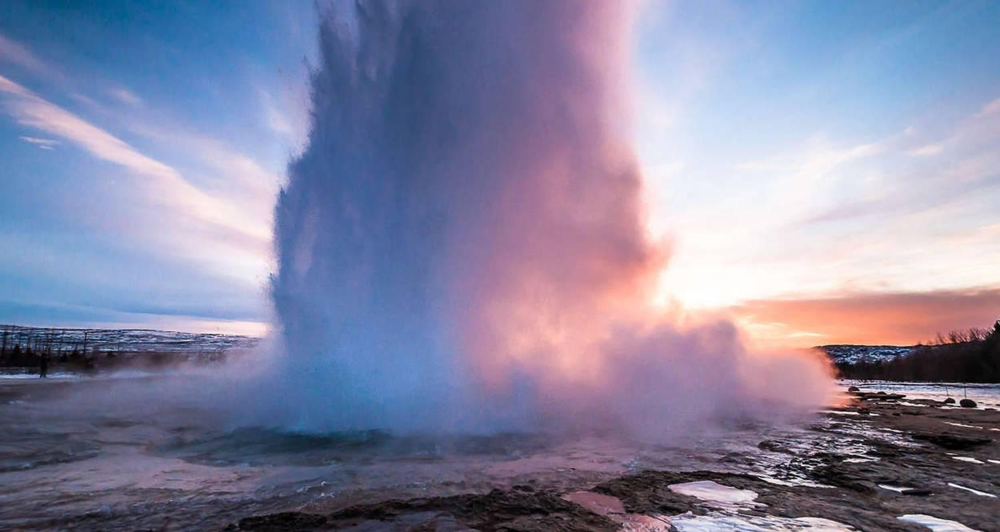

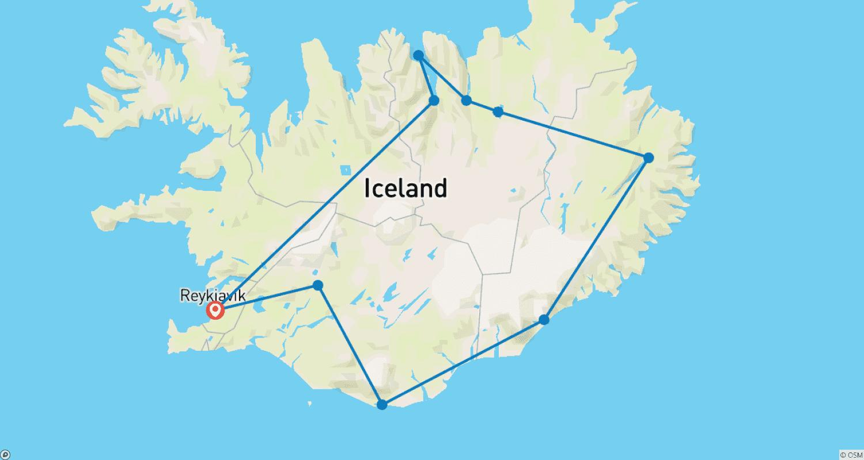

Tour ID: 156087  
Tour Name: East Greenland and Iceland Northern Lights

Tour destinations: ['Reykjavik', 'Latrabjarg']

Tour destinations images:

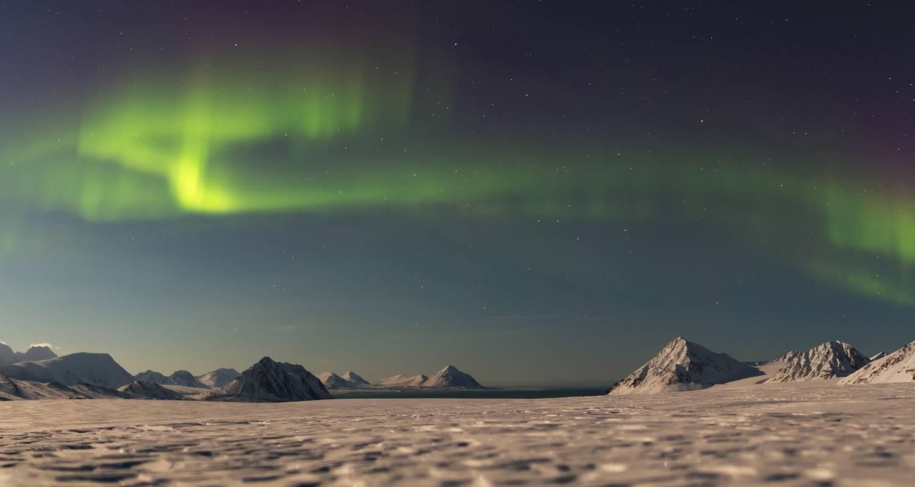

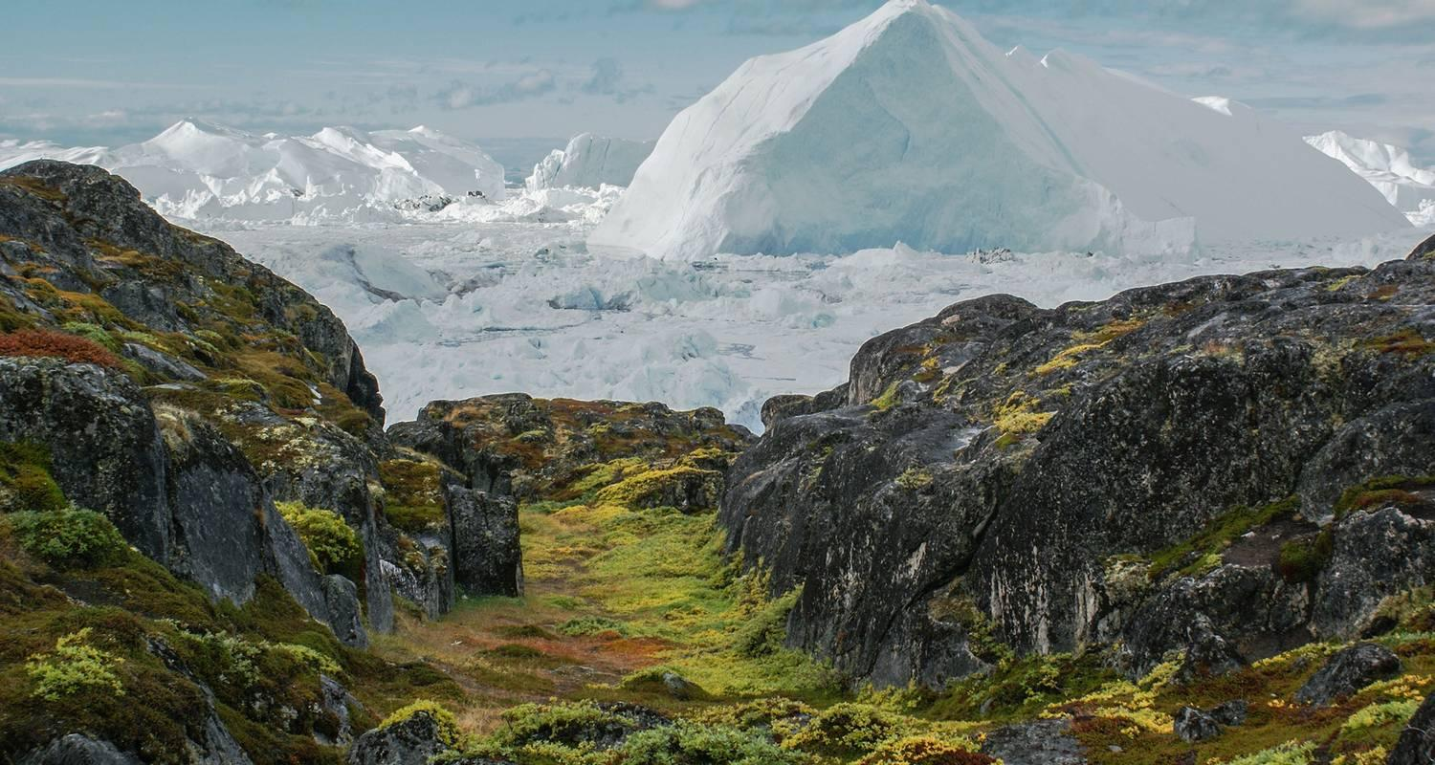

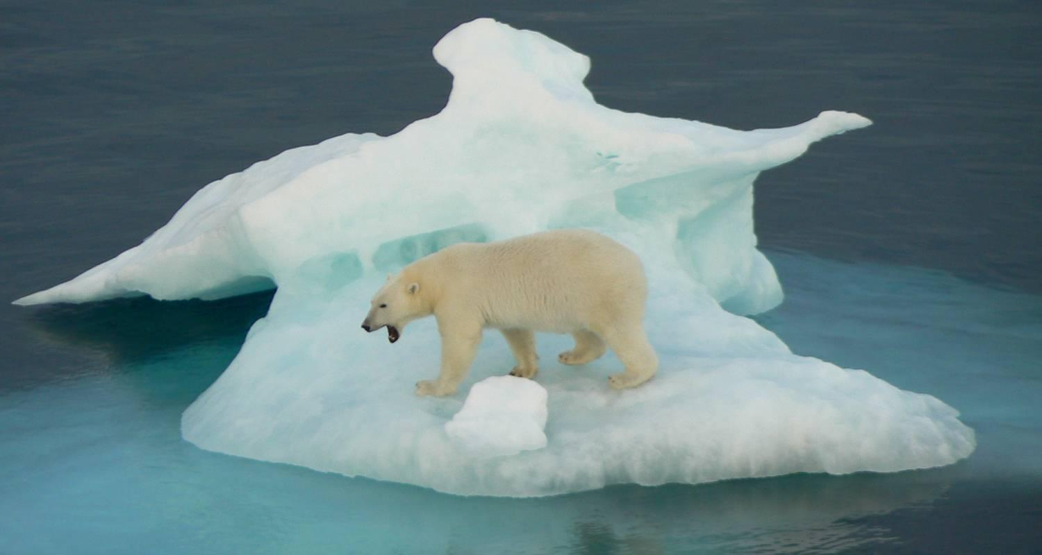

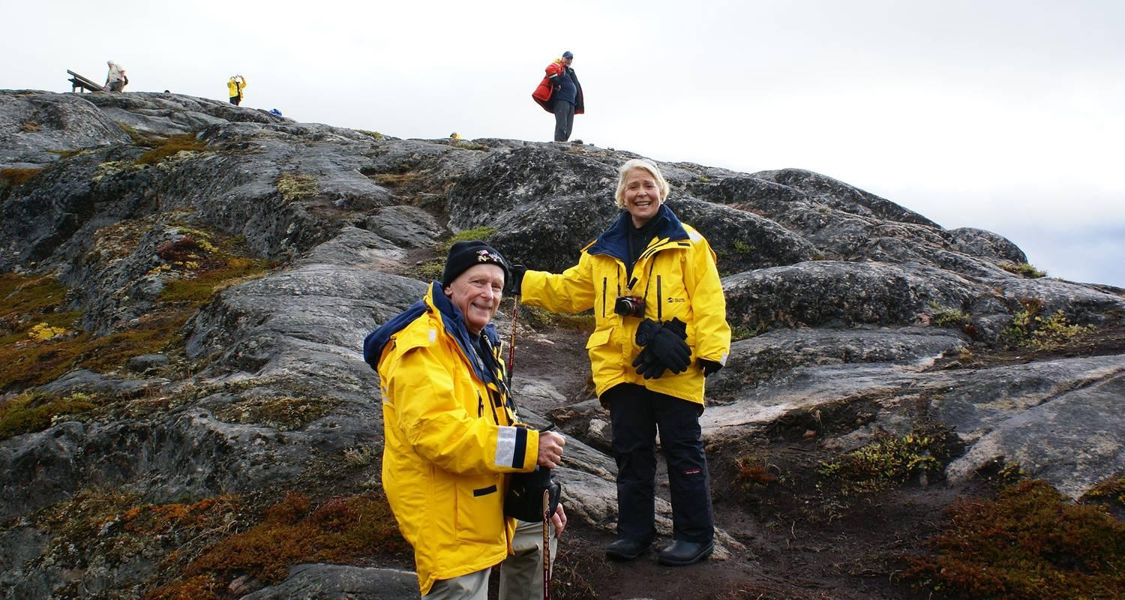

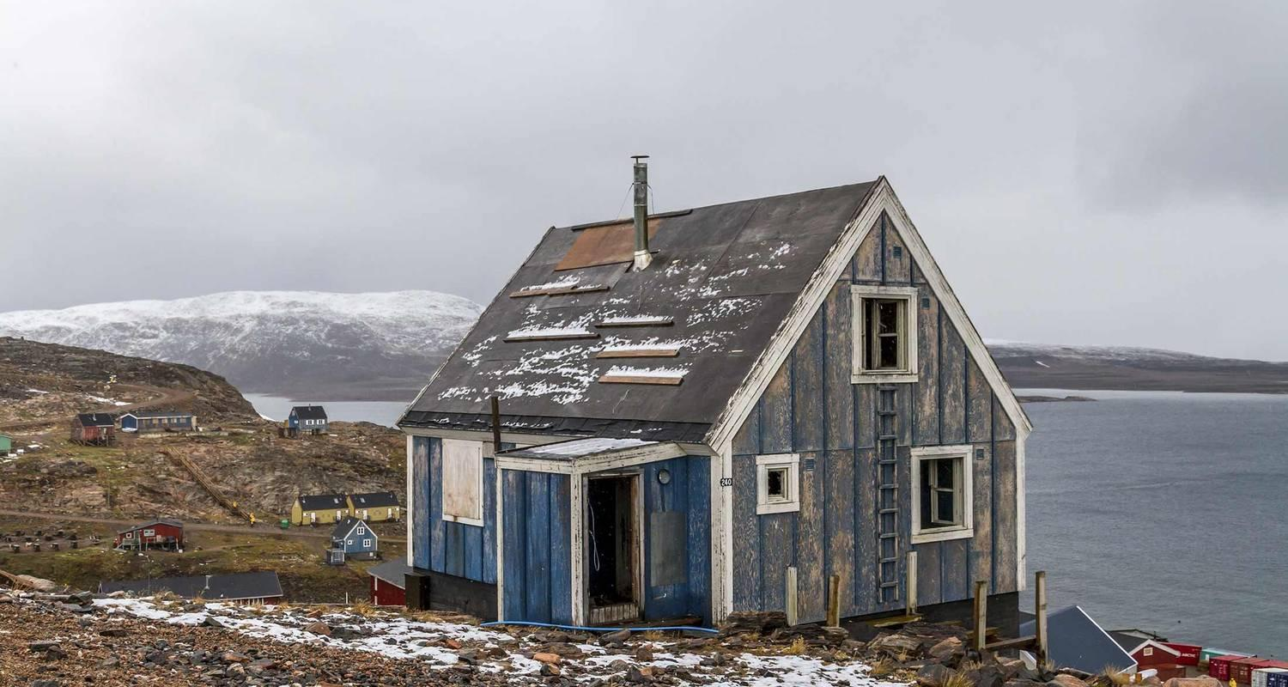

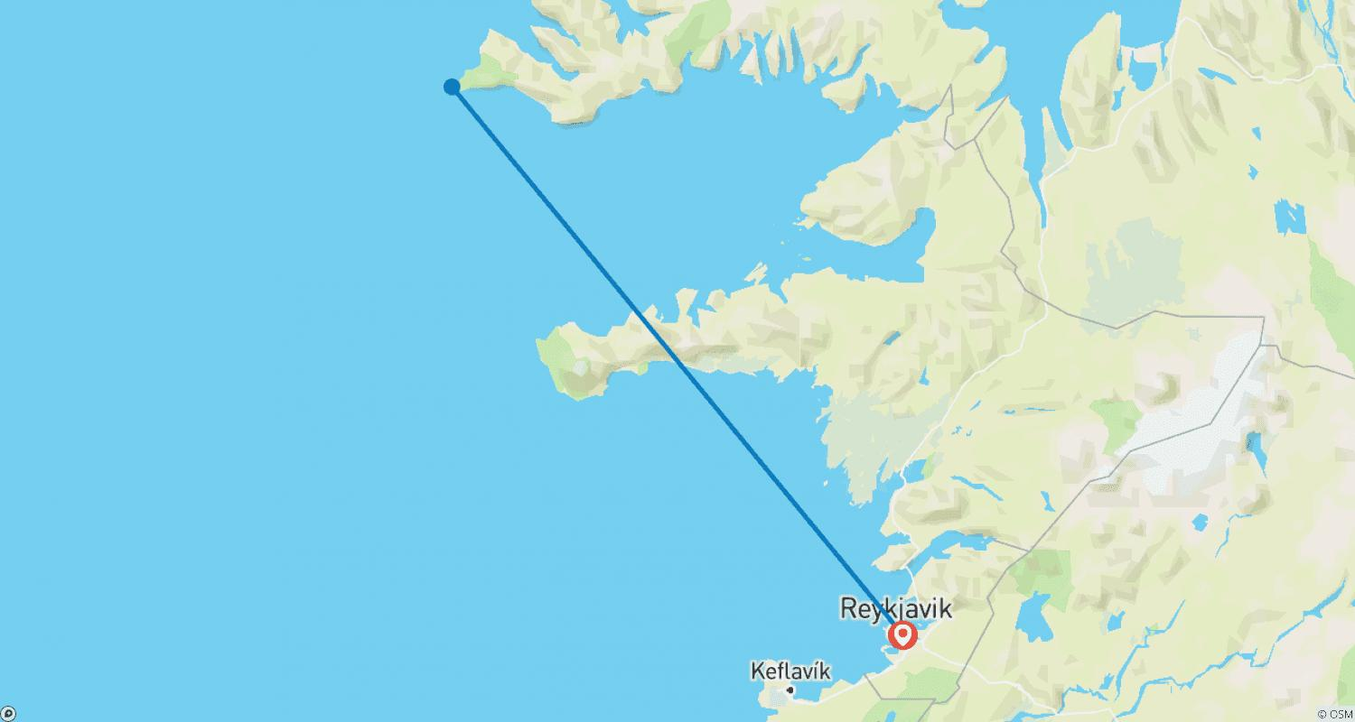

Tour ID: 159616  
Tour Name: Iceland Family Journey: Geysers, Glaciers, and Fjords

Tour destinations: ['Reykjavik', 'Hveragerdi', 'Gullfoss', 'Geysir', 'Thingvellir National Park', 'Laugarvatn', 'Skogafoss', 'Vik']

Tour destinations images:

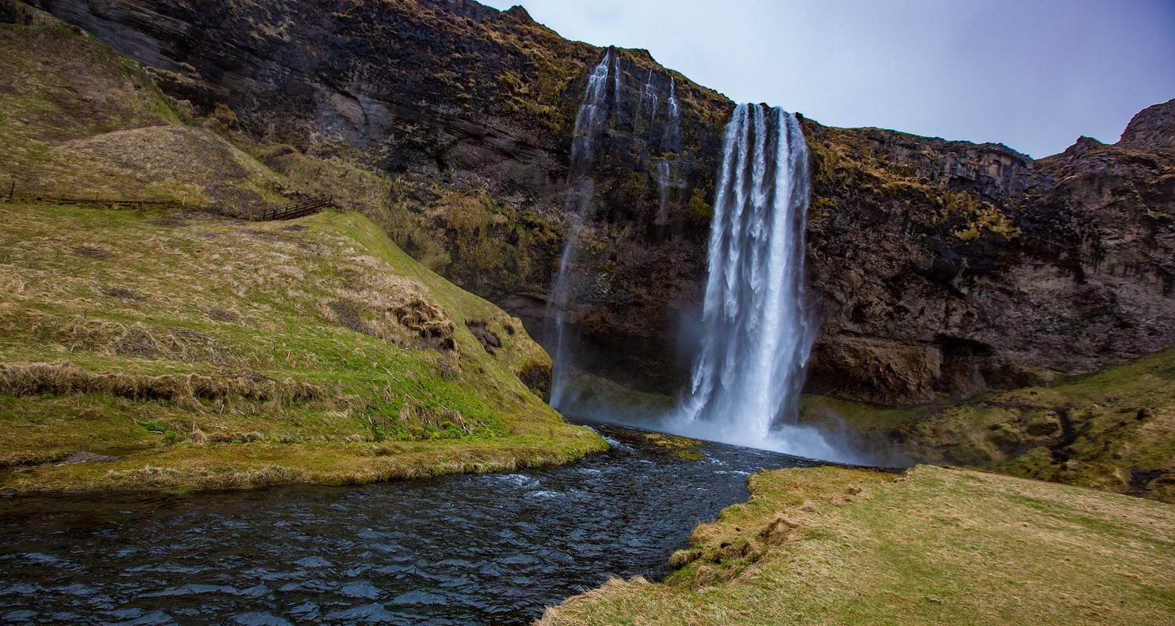

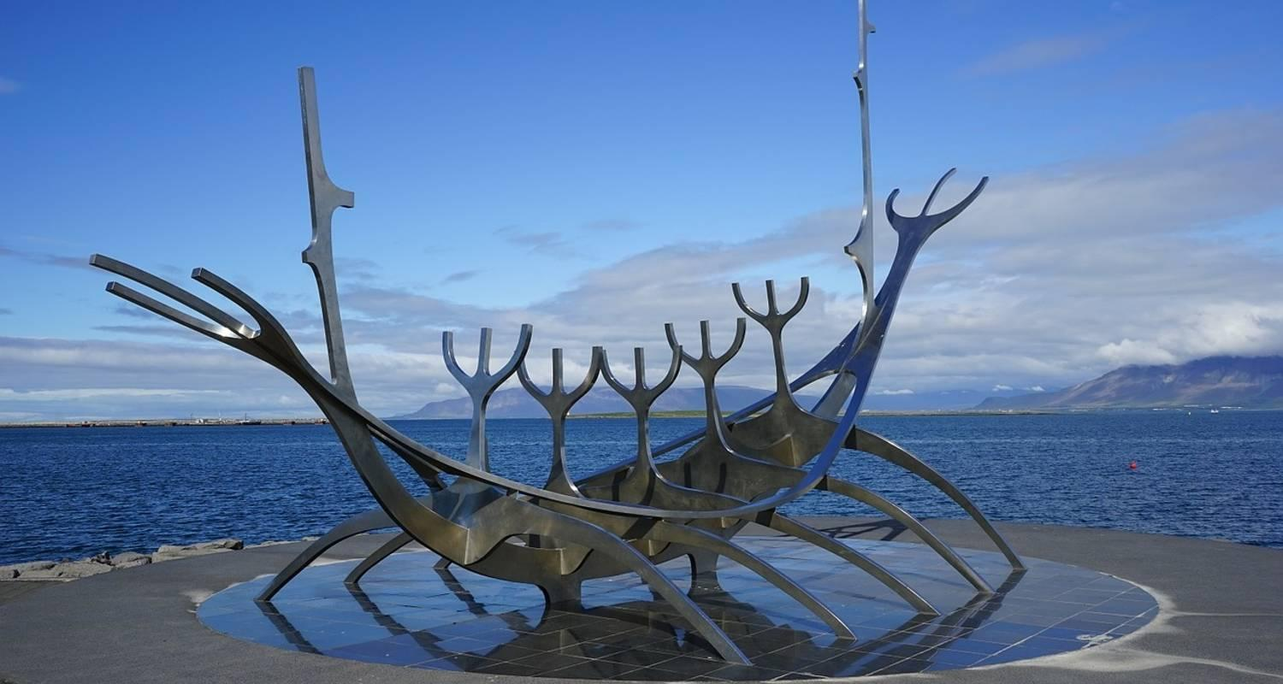

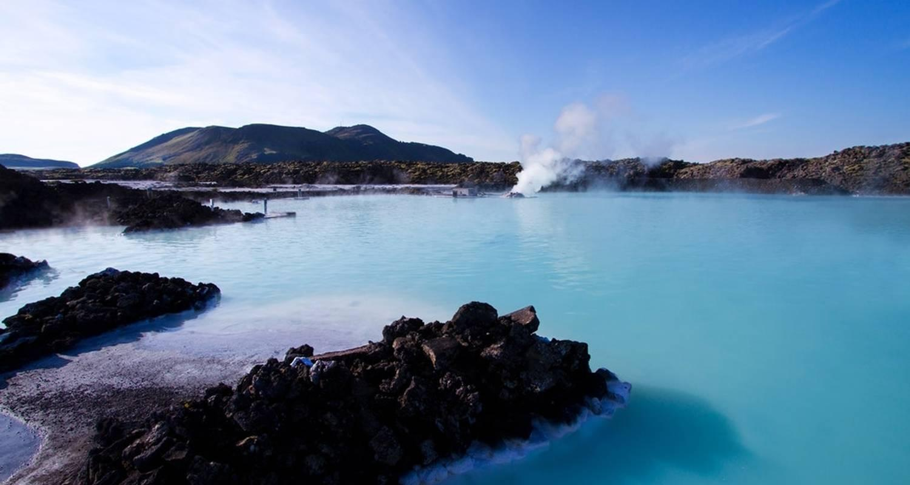

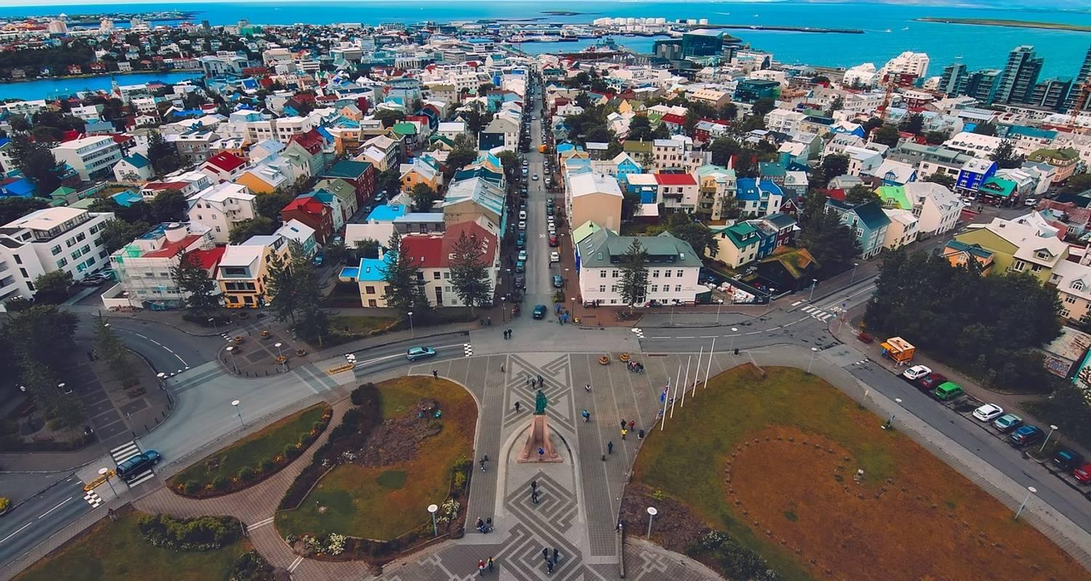

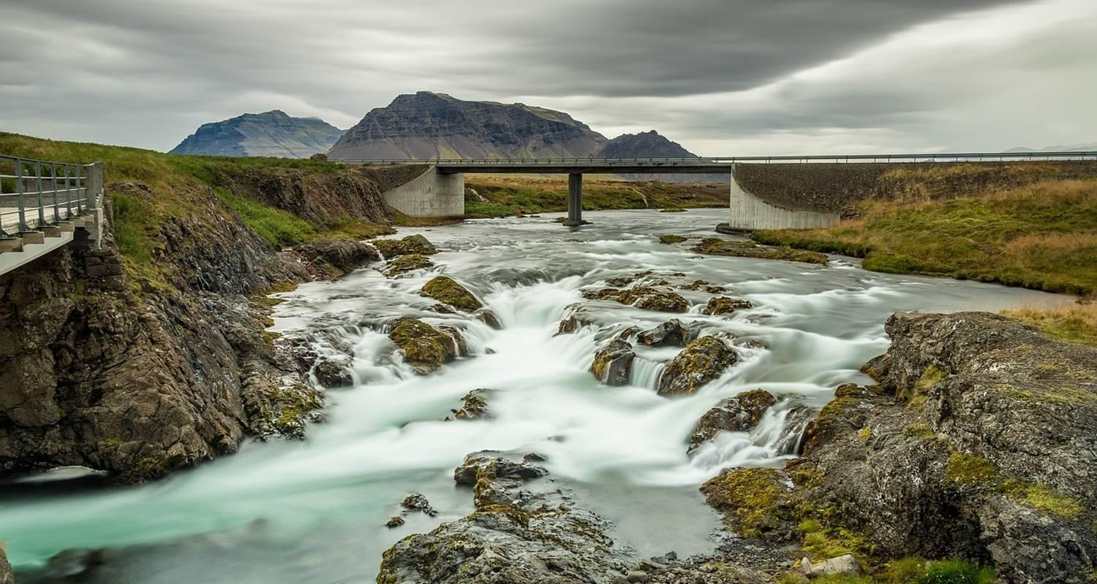

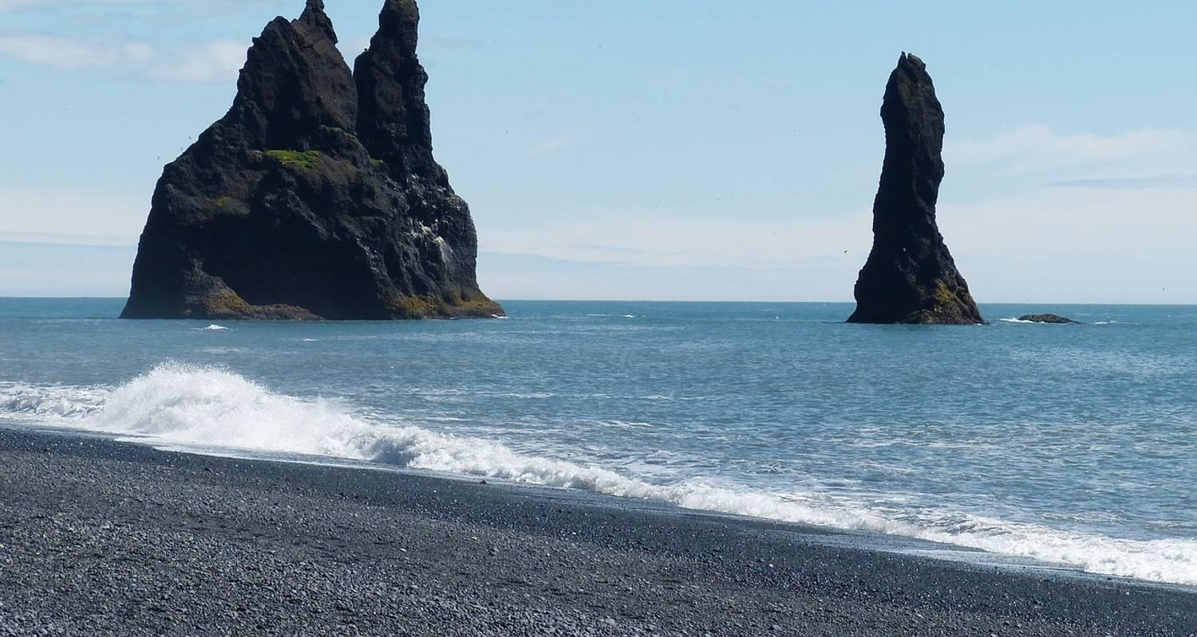

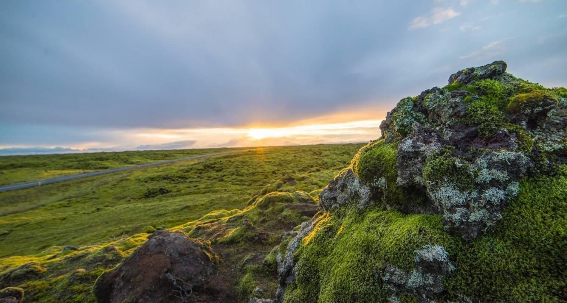

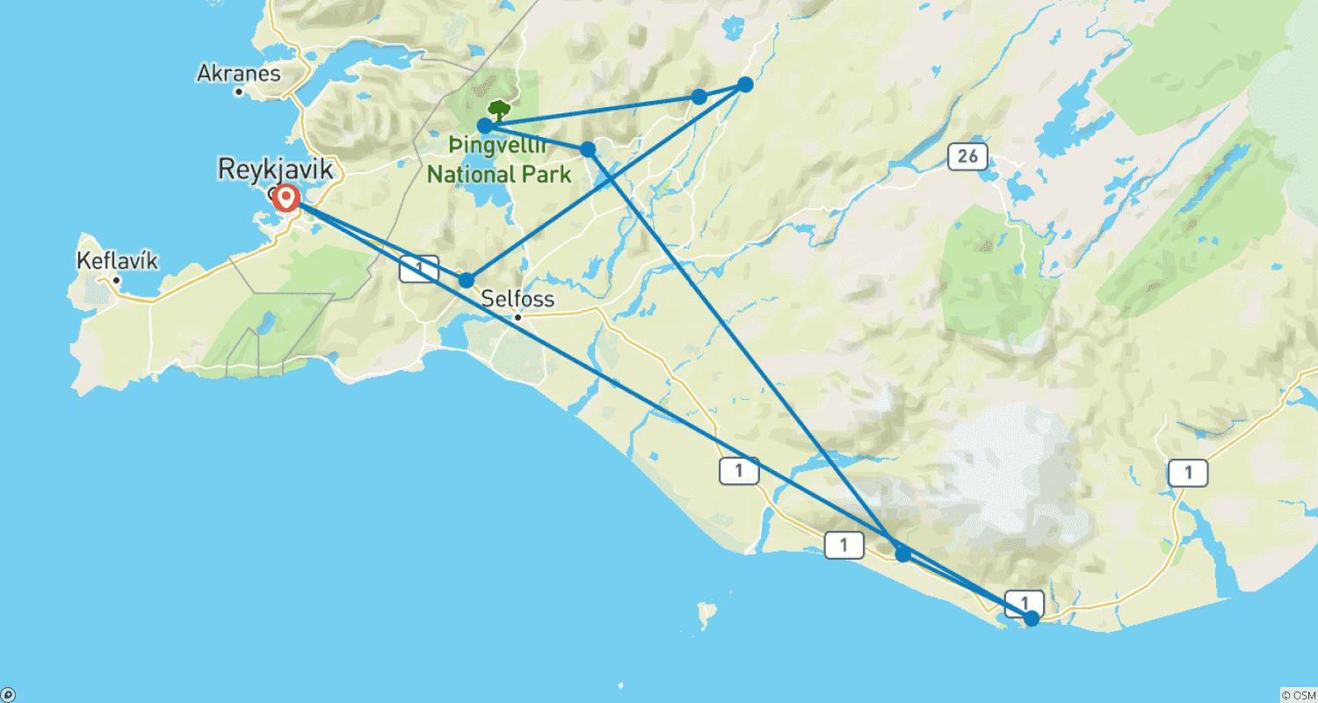

Tour ID: 162826  
Tour Name: NORTH ATLANTIC EXPEDITION , A TRUE ARCTIC ADVENTURE - ARCTIC 2024

Tour destinations: ['Reykjavik', 'Longyearbyen']

Tour destinations images:

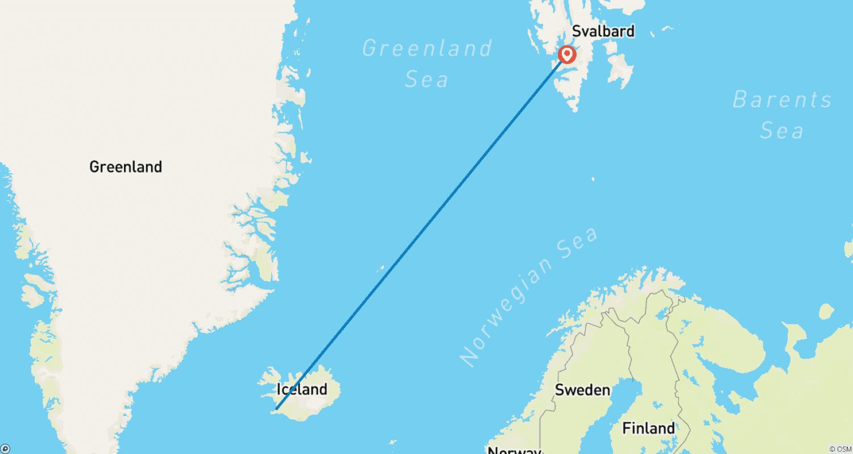

Tour ID: 164374  
Tour Name: 6 Days Iceland | Golden Circle, South Coast, Snæfellsnes, Reykjavik City Tour & Airport Transfer (Group Tour)

Tour destinations: ['Keflavik', 'Reykjavik', 'Thingvellir National Park', 'Geysir', 'Gullfoss', 'Kirkjufell Mountain', 'Djupalonssandur', 'Arnarstapi', 'Skogafoss', 'Jokulsarlon']

Tour destinations images:

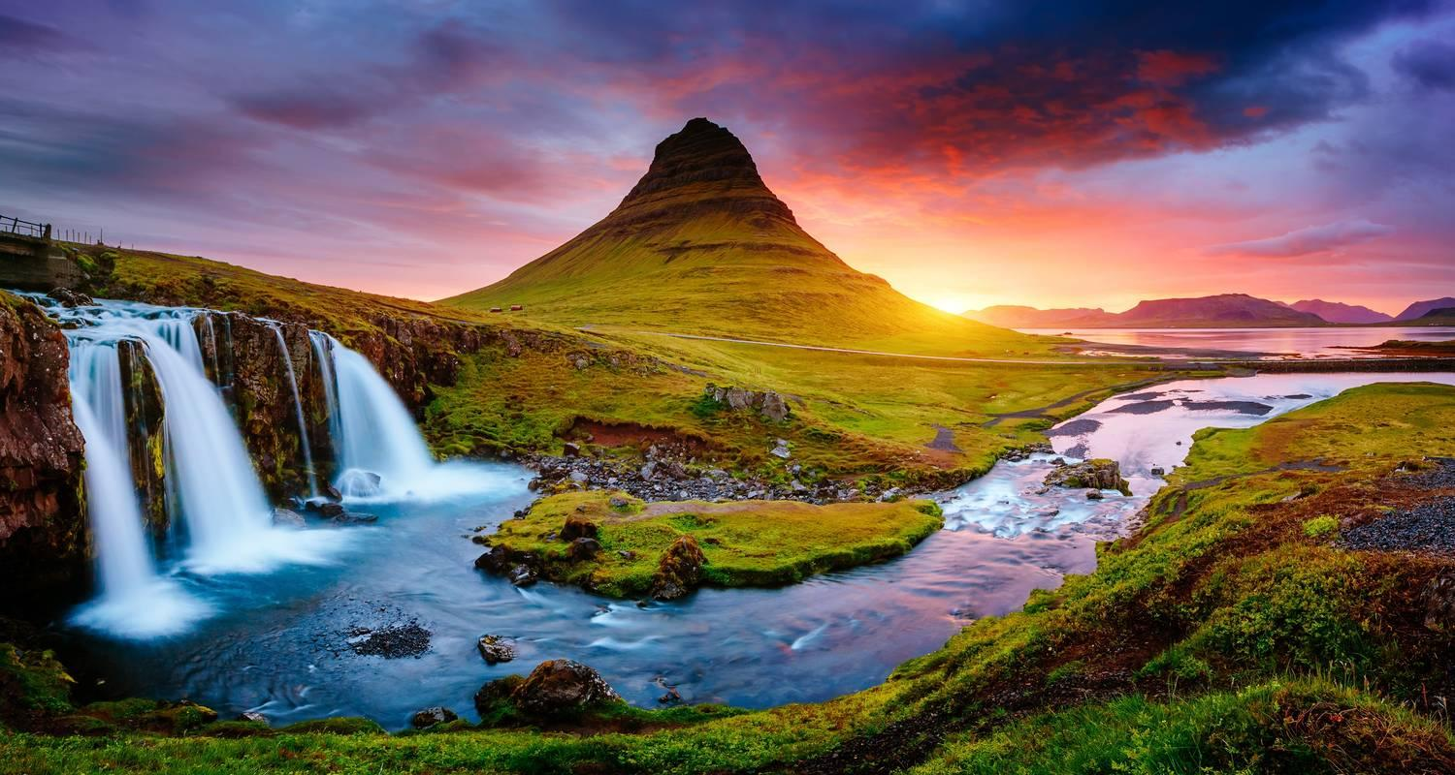

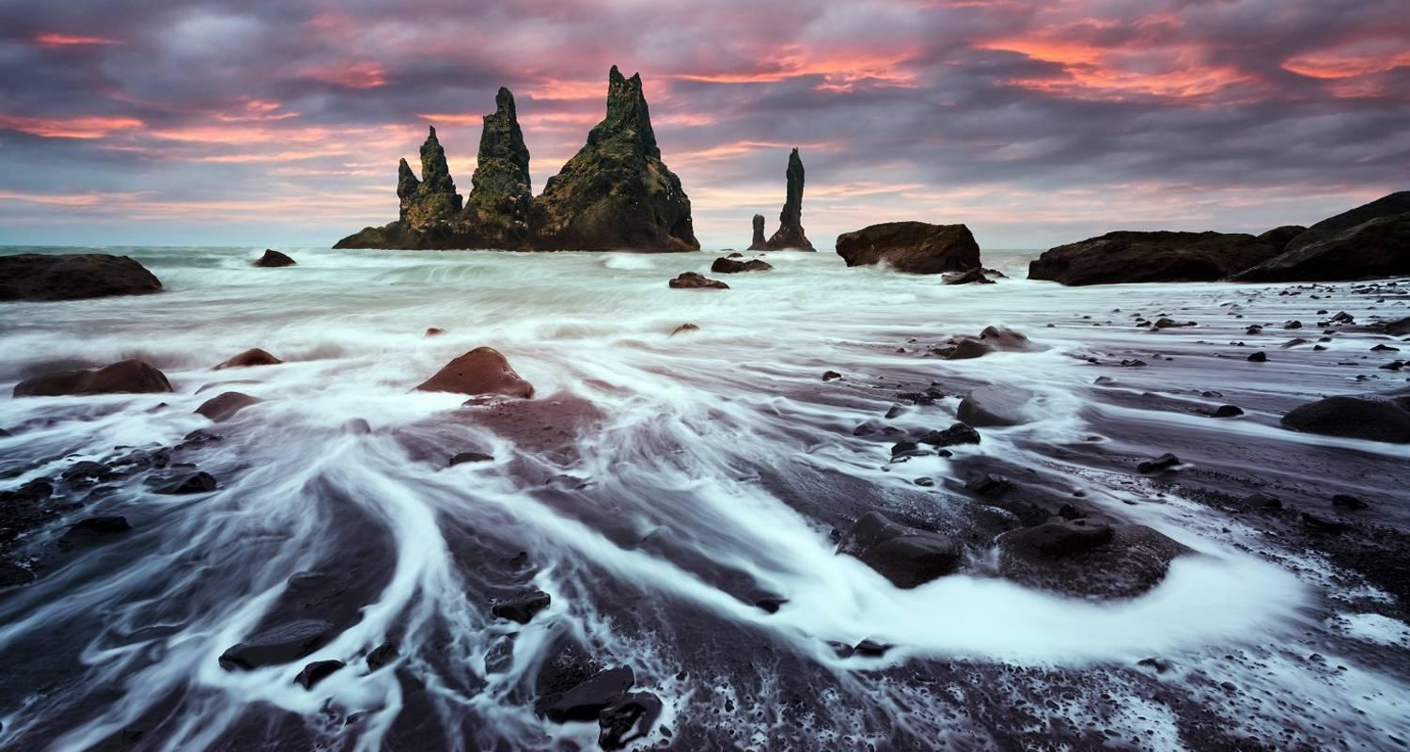

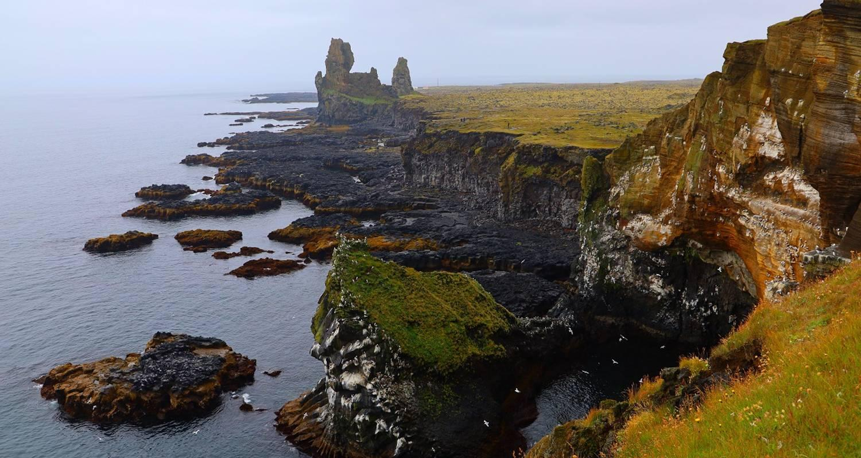

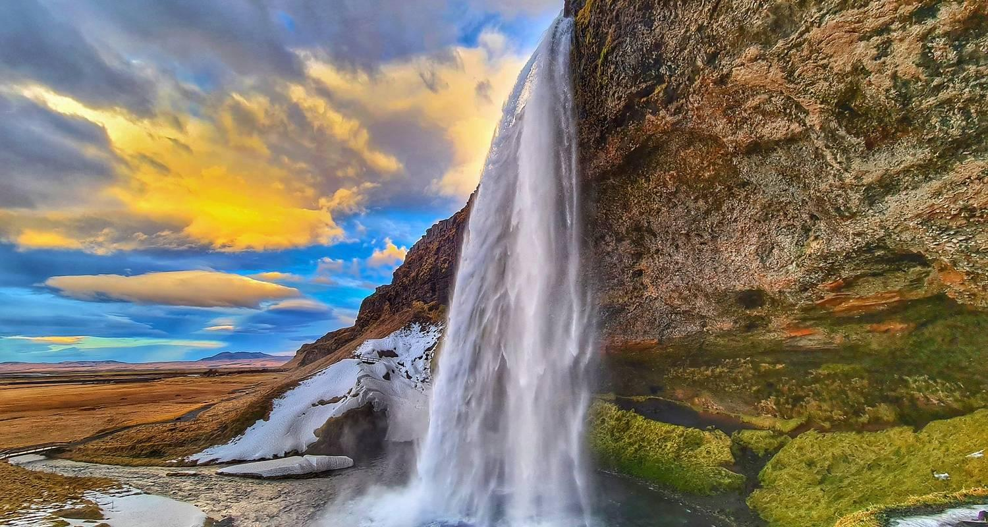

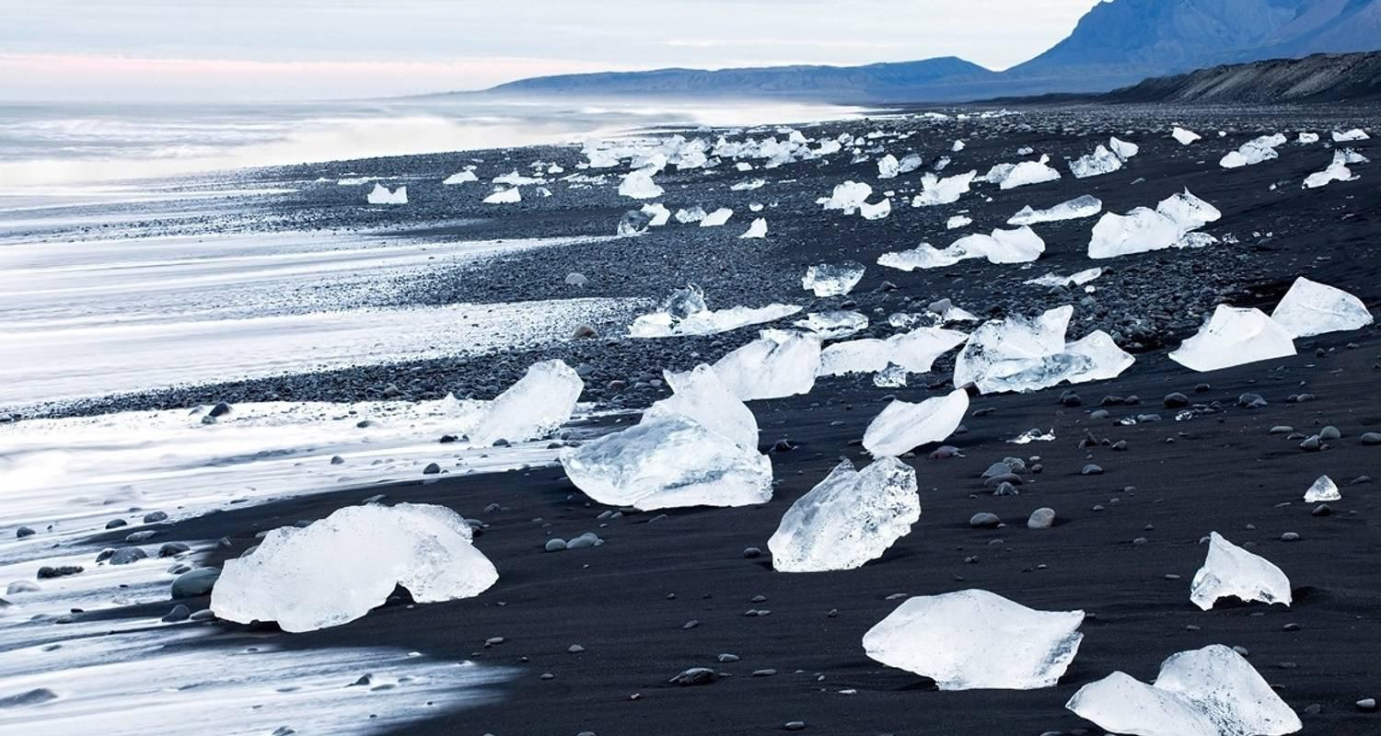

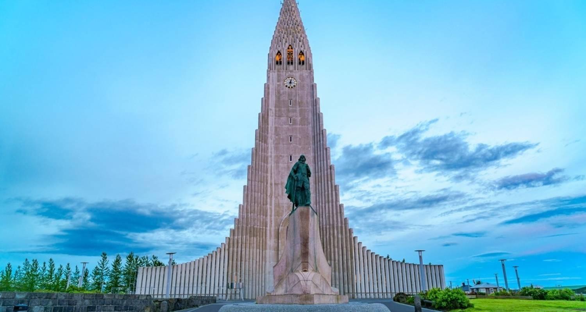

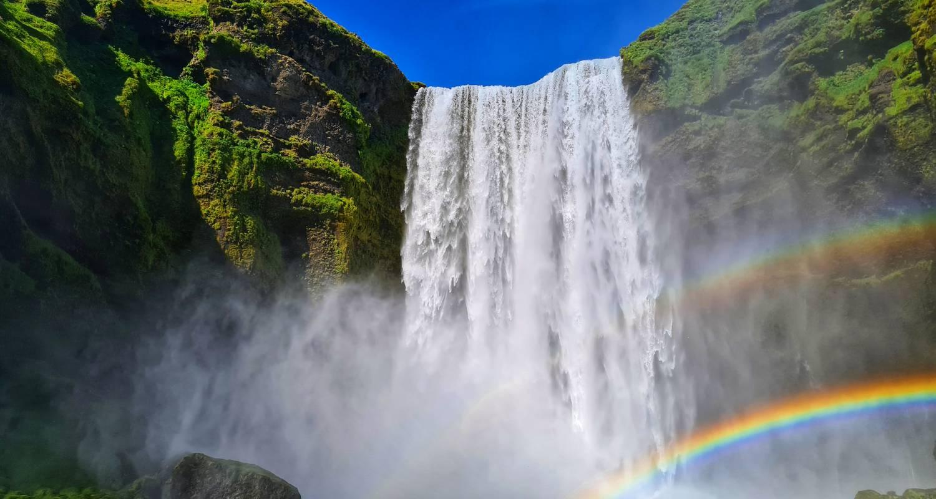

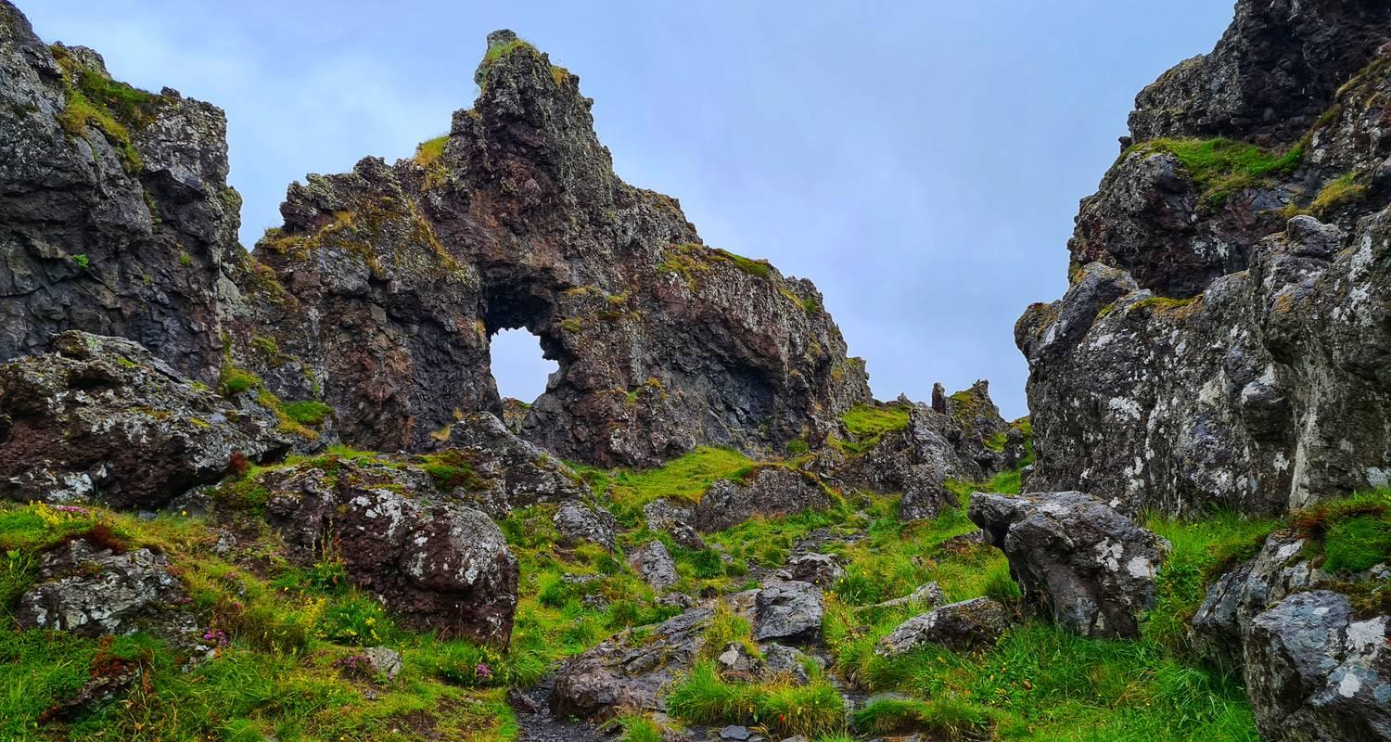

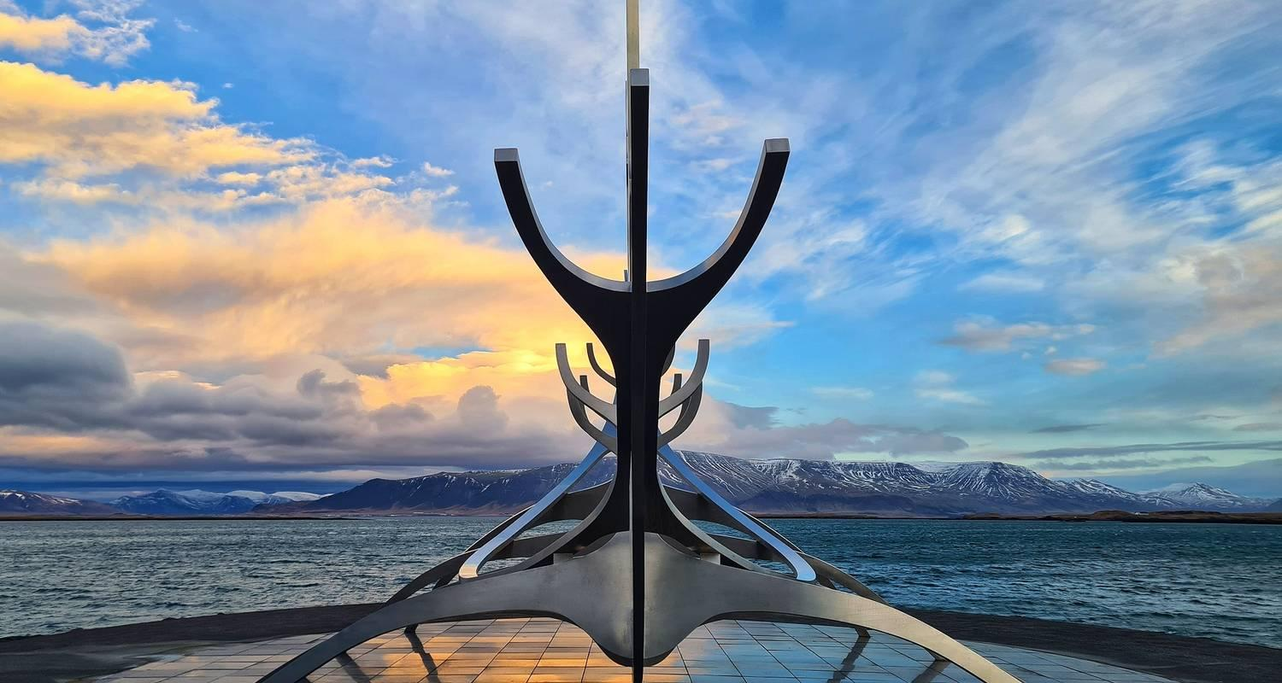

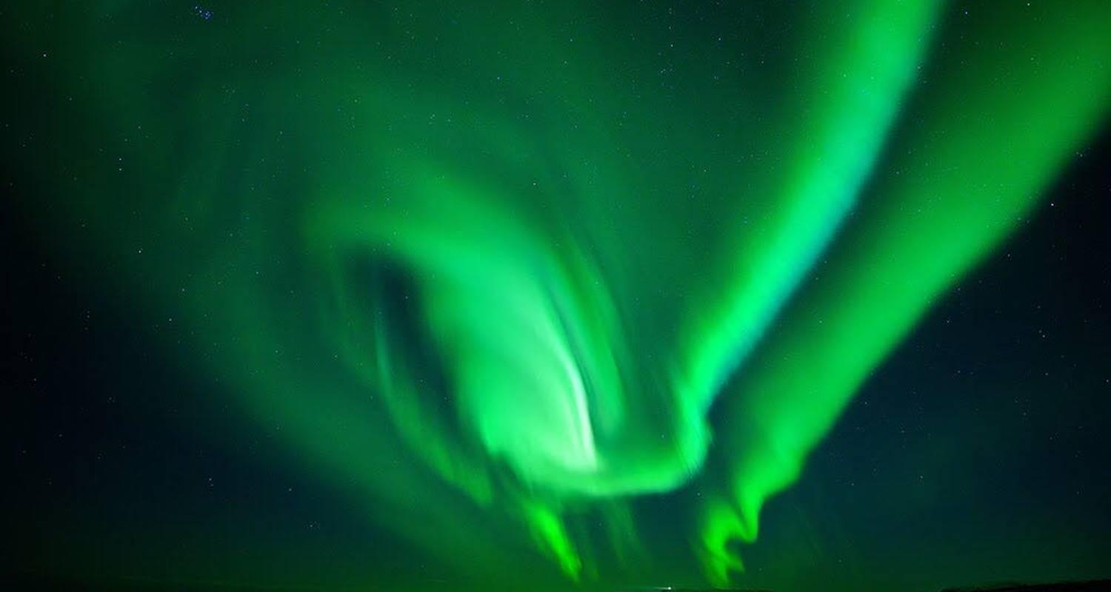

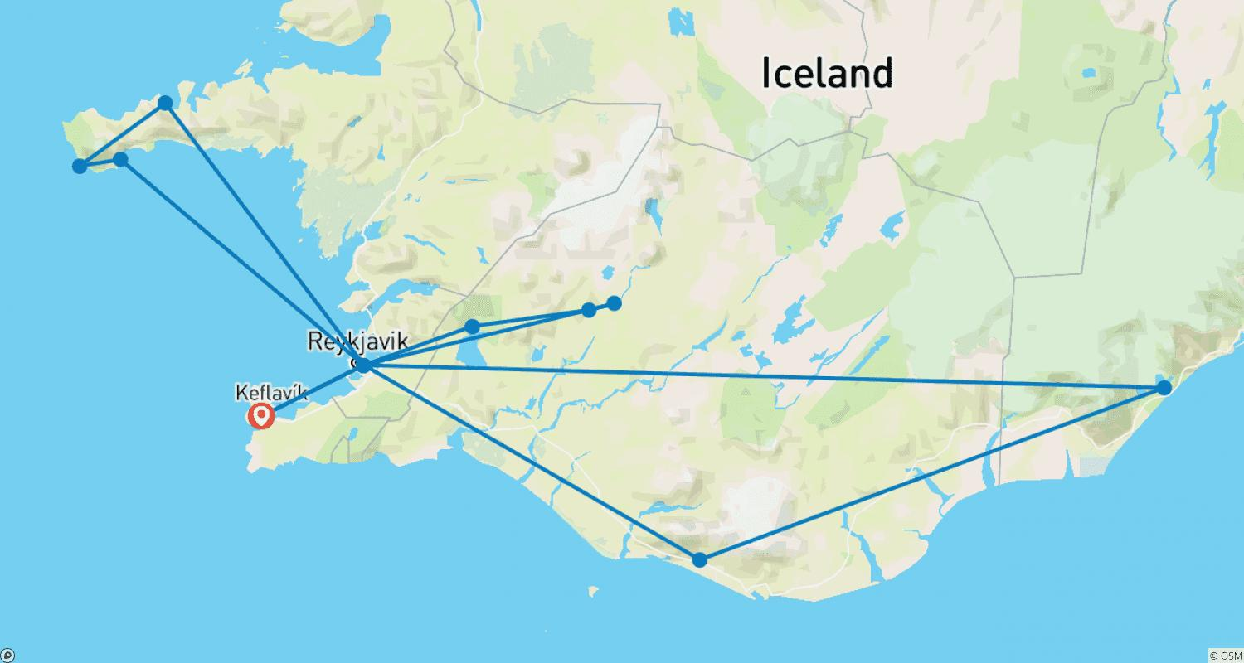

Tour ID: 169439  
Tour Name: Laugavegur Trek with glacier hike - 5 Day (Huts)

Tour destinations: ['Reykjavik', 'Landmannalaugar', 'Hrafntinnusker Mountain', 'Emstrur', 'Thorsmork Nature Reserve', 'Hella', 'Skogafoss', 'Seljaland', 'Solheimajokull']

Tour destinations images:

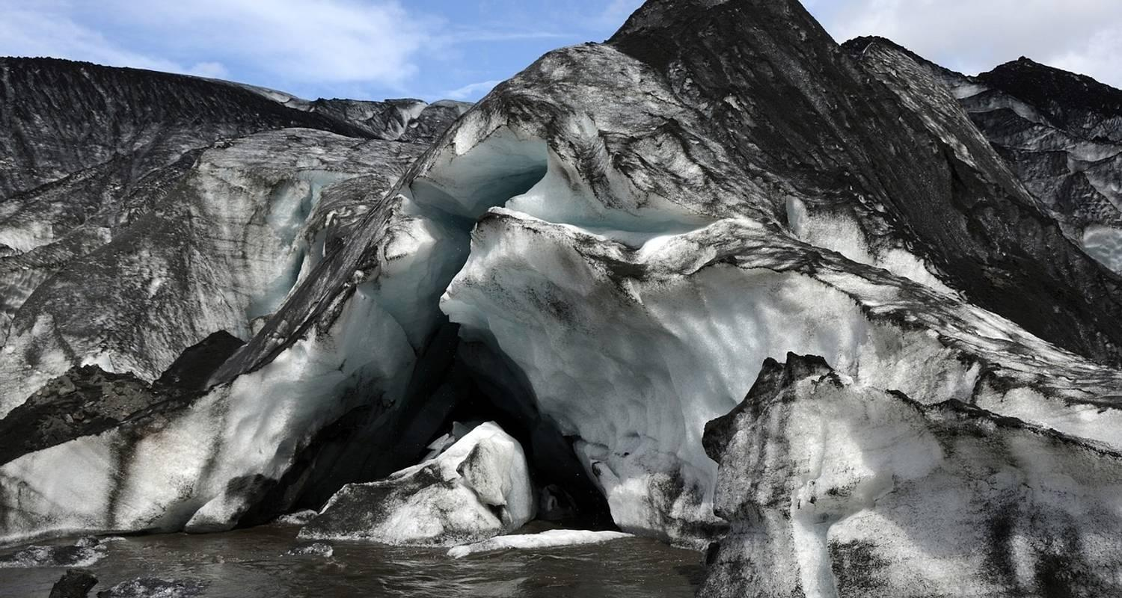

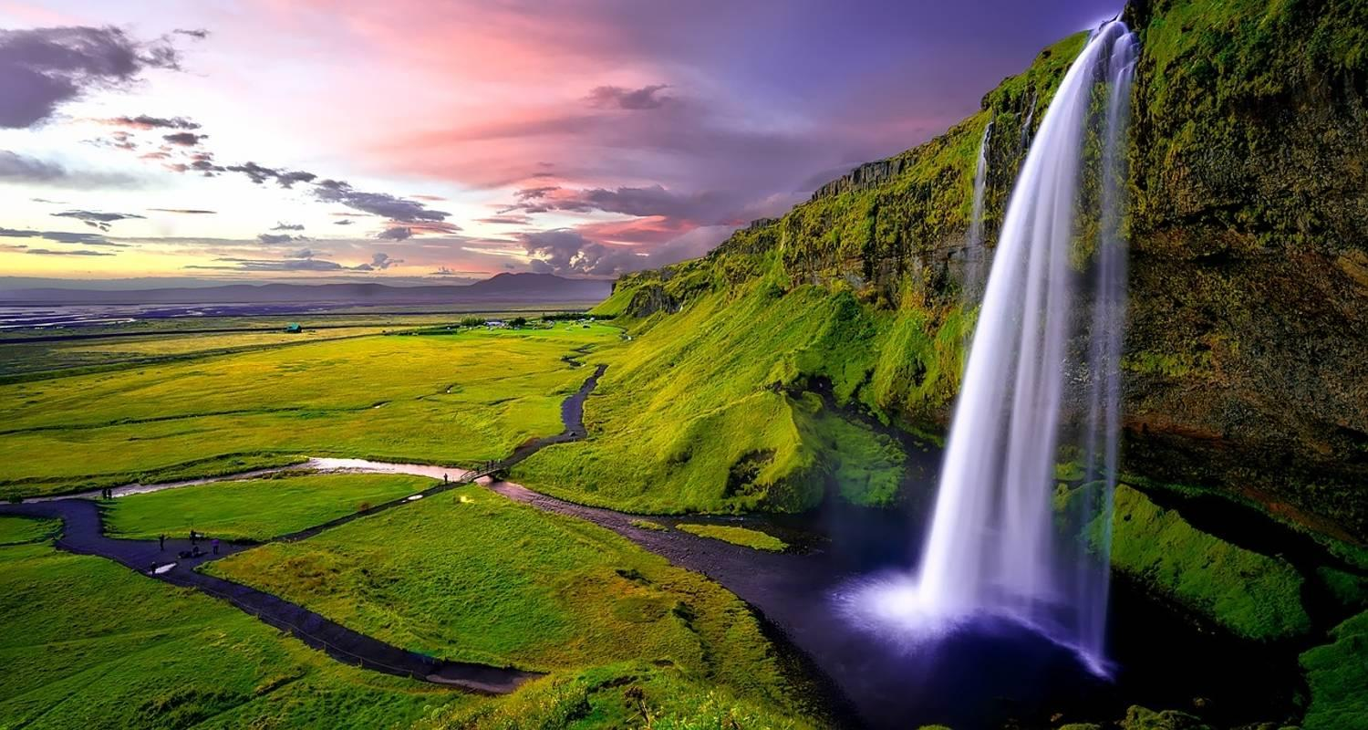

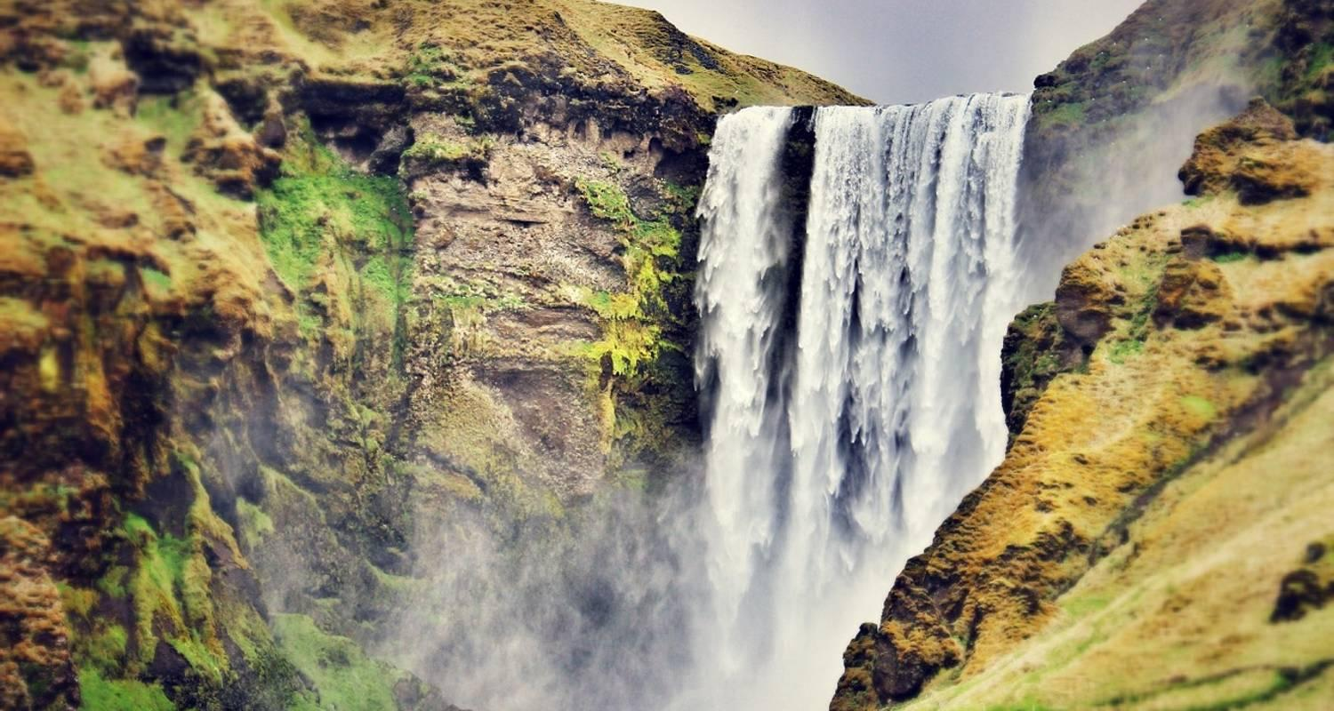

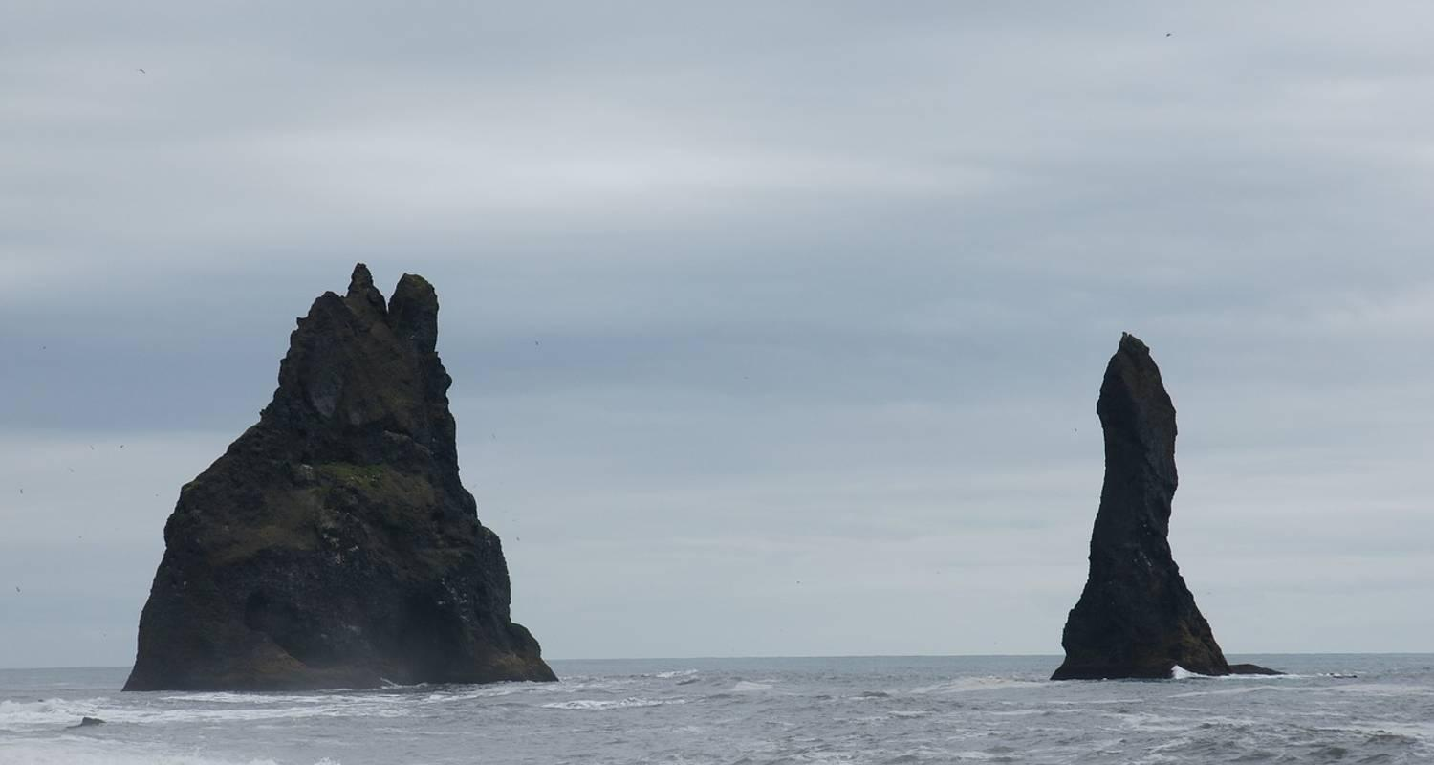

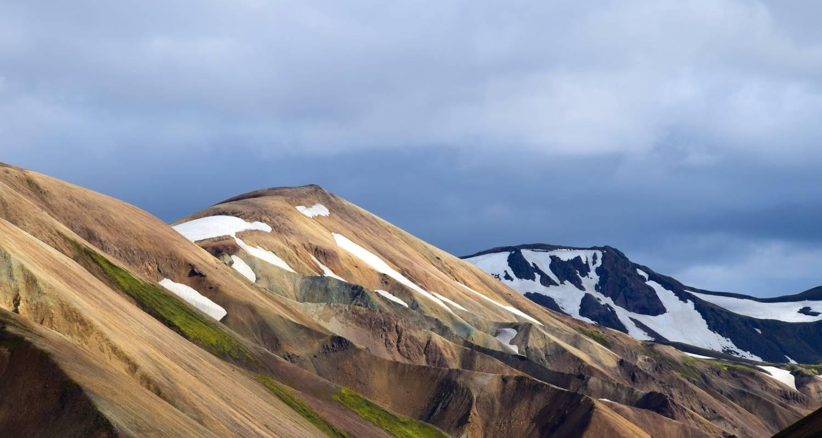

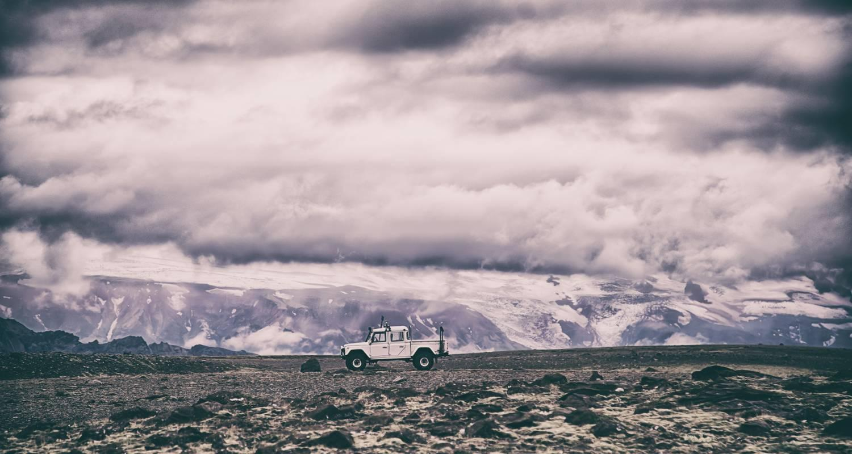

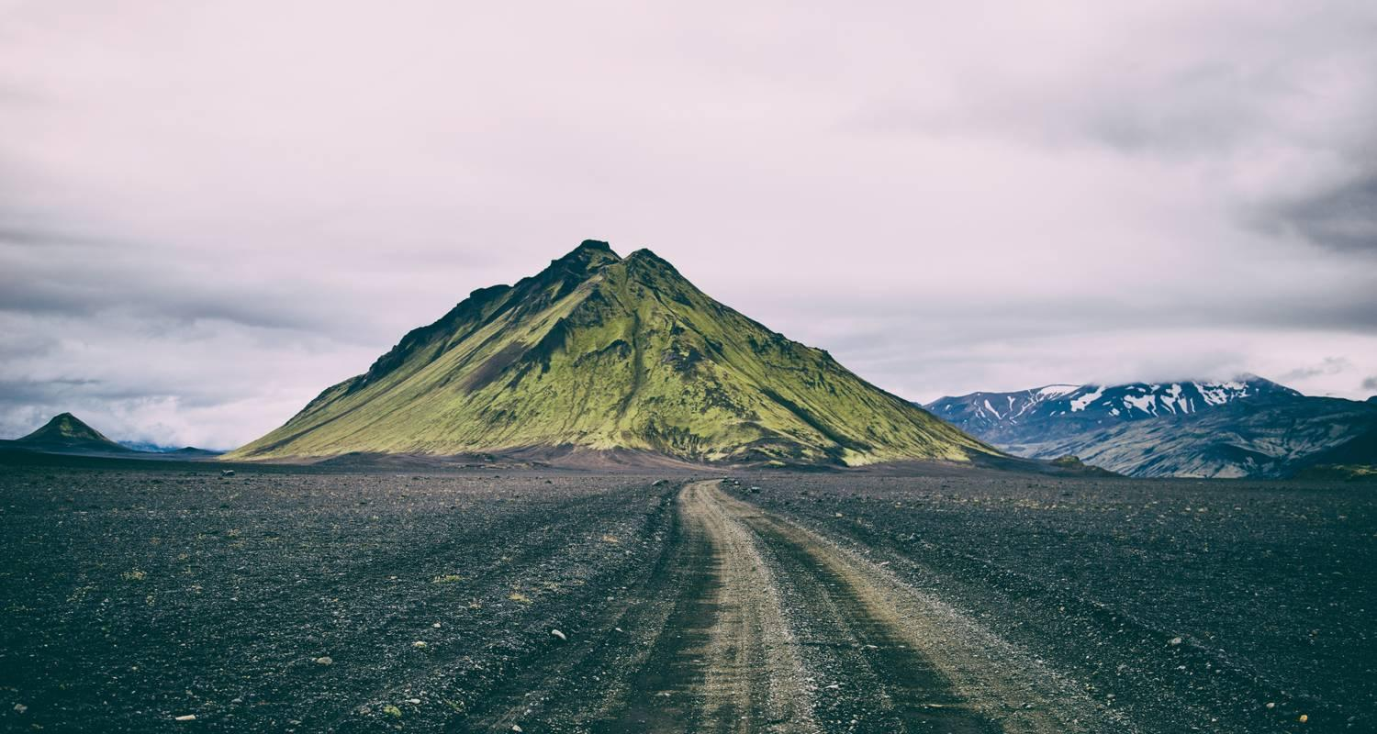

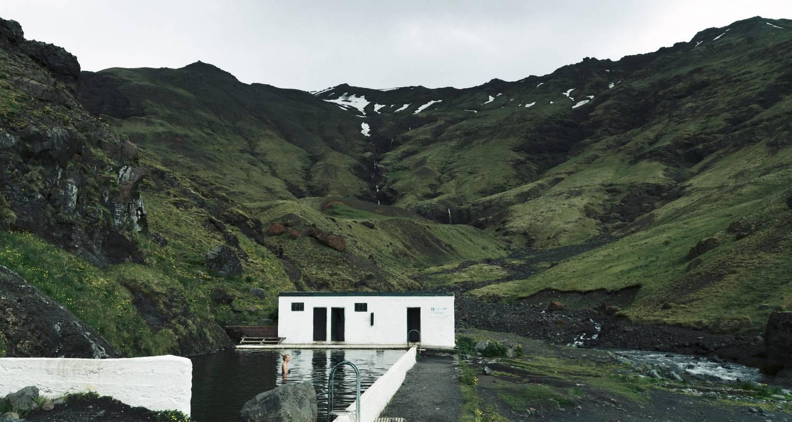

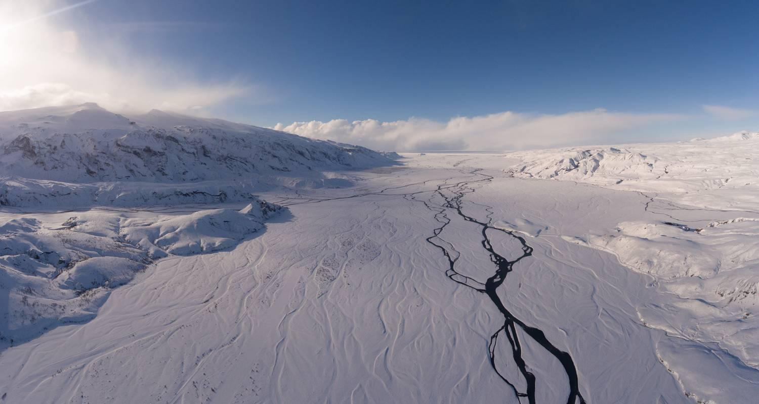

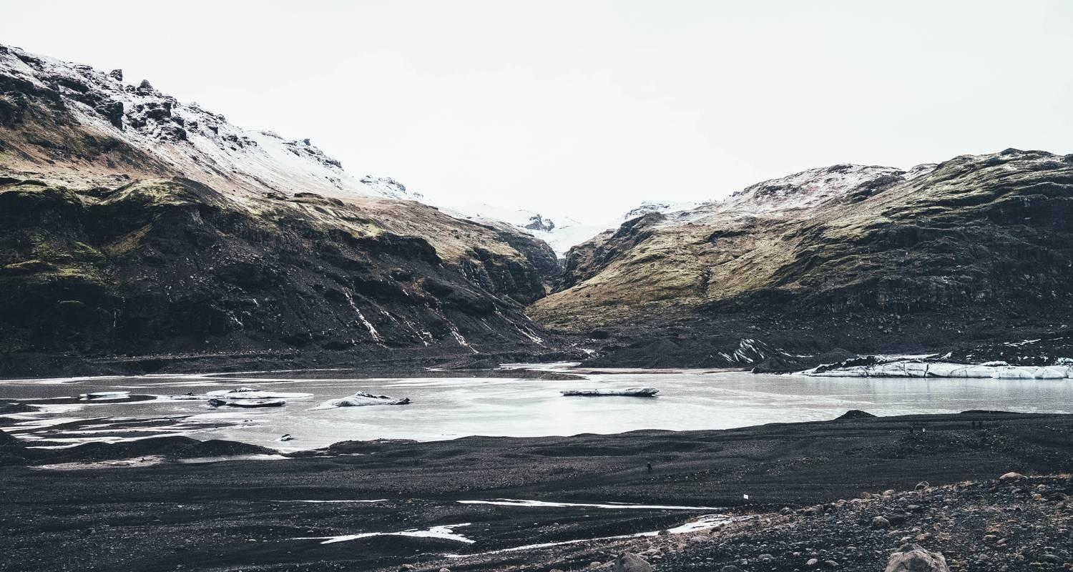

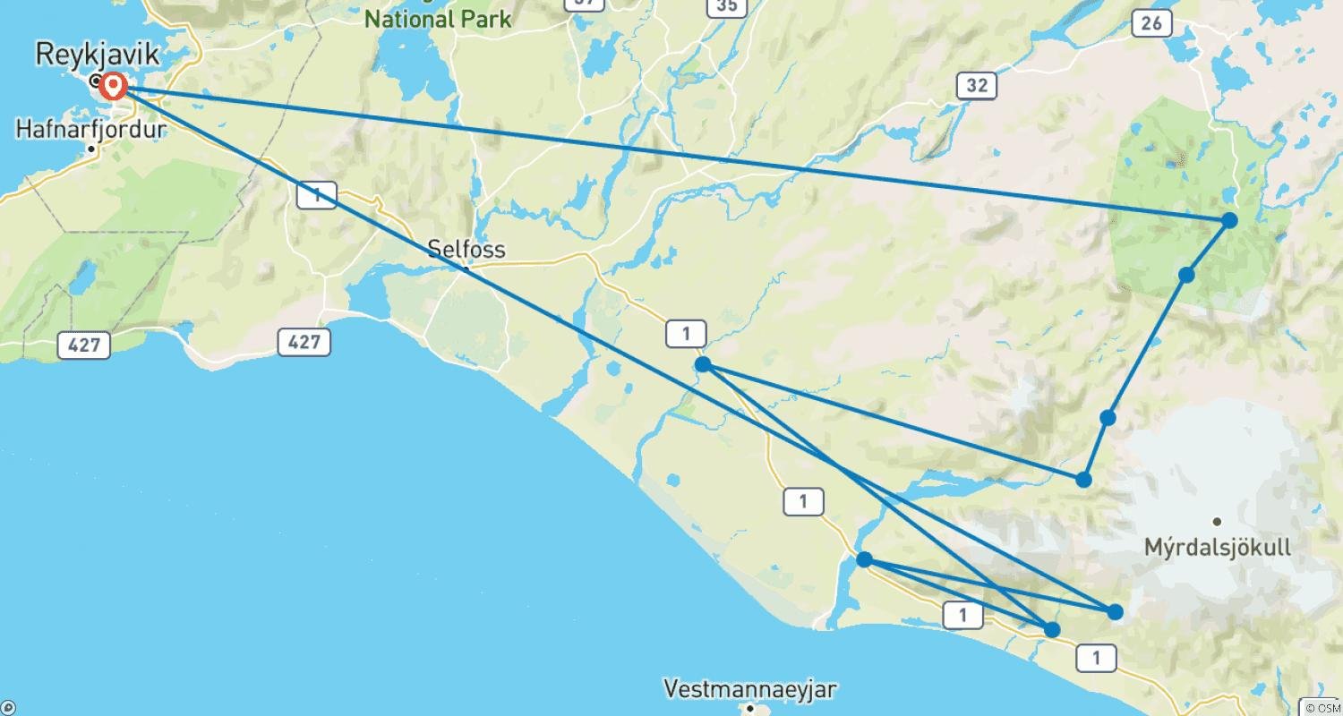

Tour ID: 171036  
Tour Name: 7 day Self-drive tour | Winter Wonders and Delicious Detours

Tour destinations: ['Keflavik', 'Reykjavik', 'Geysir', 'Gullfoss', 'Eyjafjallajokull', 'Skogafoss', 'Vik', 'Skaftafell', 'Jokulsarlon', 'Thingvellir National Park', 'Borgarnes', 'Snaefellsjokull National Park', 'Blue Lagoon', 'Reykjanesfólkvangur Reserve']

Tour destinations images:

